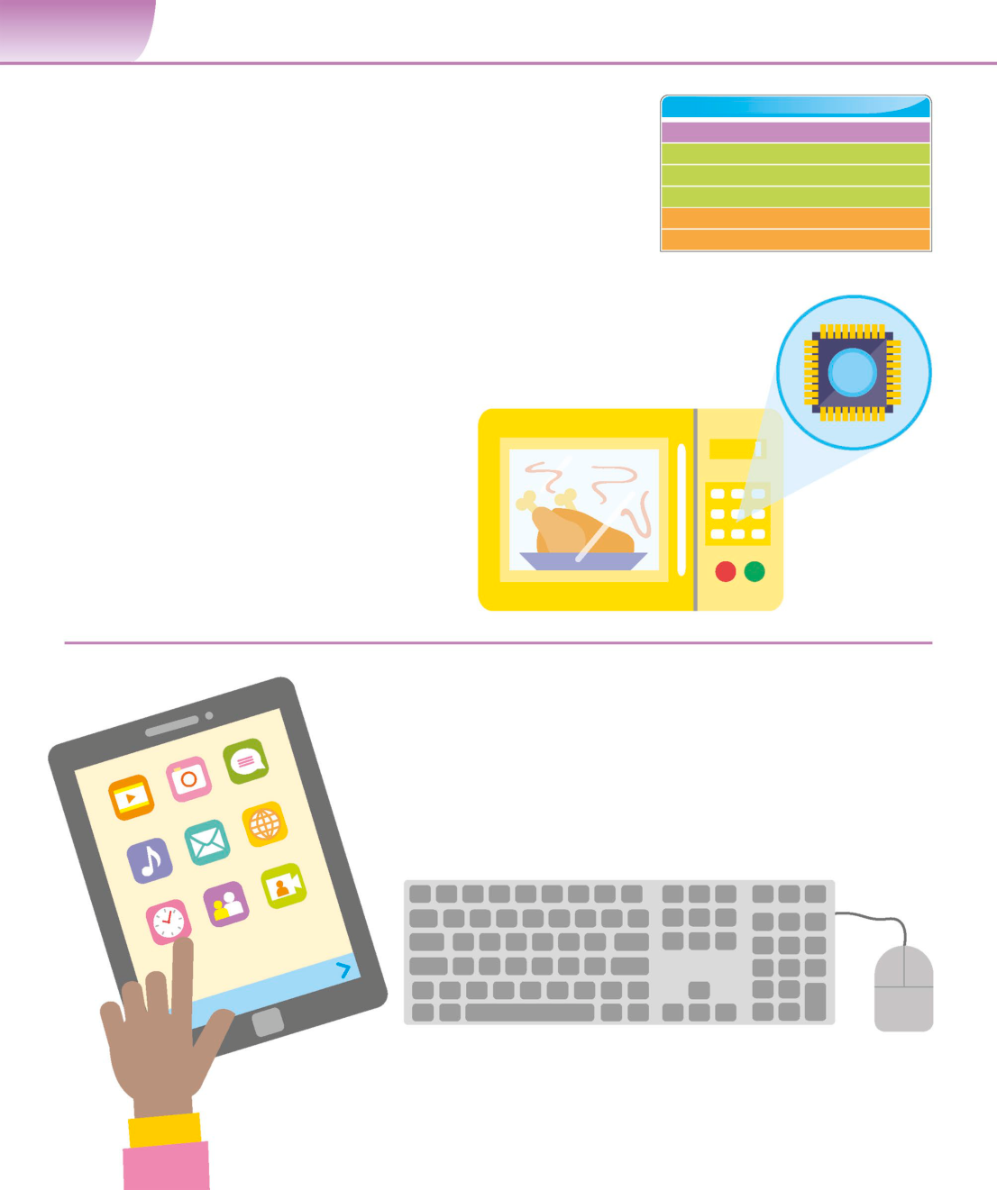

**14**  **G E T T I N G S TA R T E D**

|  |  |  |
| --- | --- | --- |
| Computers are | **SEE ALSO** | **16–17›** |
| Computing for you |
| everywhere | Insideacomputer | **34–35›** |
| Peripheraldevices | **36–37›** |
| The computer chip | **38–39›** |

What is hardware? **48–49›**

|  |  |  |
| --- | --- | --- |
| **Some people feel computers are too complex for them to use** | Smartphones and tablets | **52–53›** |

**without special skills and knowledge. However, they interact**

**with computers all the time without necessarily realizing it.**

**Look closely**  Pressing the buttons on a

microwave’s control panel runs

Computers are almost everywhere, not just in the code on its internal microprocessor.

conventional setup that includes a monitor, keyboard,   
and mouse. They are also found in everyday devices   
such as mobile phones, lifts, televisions, and cars. From   
watching movies to playing games, and even making   
dinner, computers can be used to do almost anything.

▷**Household devices**

Many household devices contain computers.

Selecting a program on a microwave, for   
example, actually runs a small program on   
the computer embedded in the device.

**Hardware and software**

The physical parts of a computer are called hardware. These   
include things we can see, such as the monitor and computer   
case, as well as things we can’t see, such as the motherboard and   
microprocessor inside the computer case. Things like programs,   
the operating system, and firmware (a type of program that is   
embedded into the microprocessor) are called software. They   
allow users to access the capabilities of the hardware.

△**Input devices**   
There are a lot of ways to input information and   
interact with software running on a computer.

The most common ways to do this are by using   
a keyboard, a mouse, or a touchscreen.

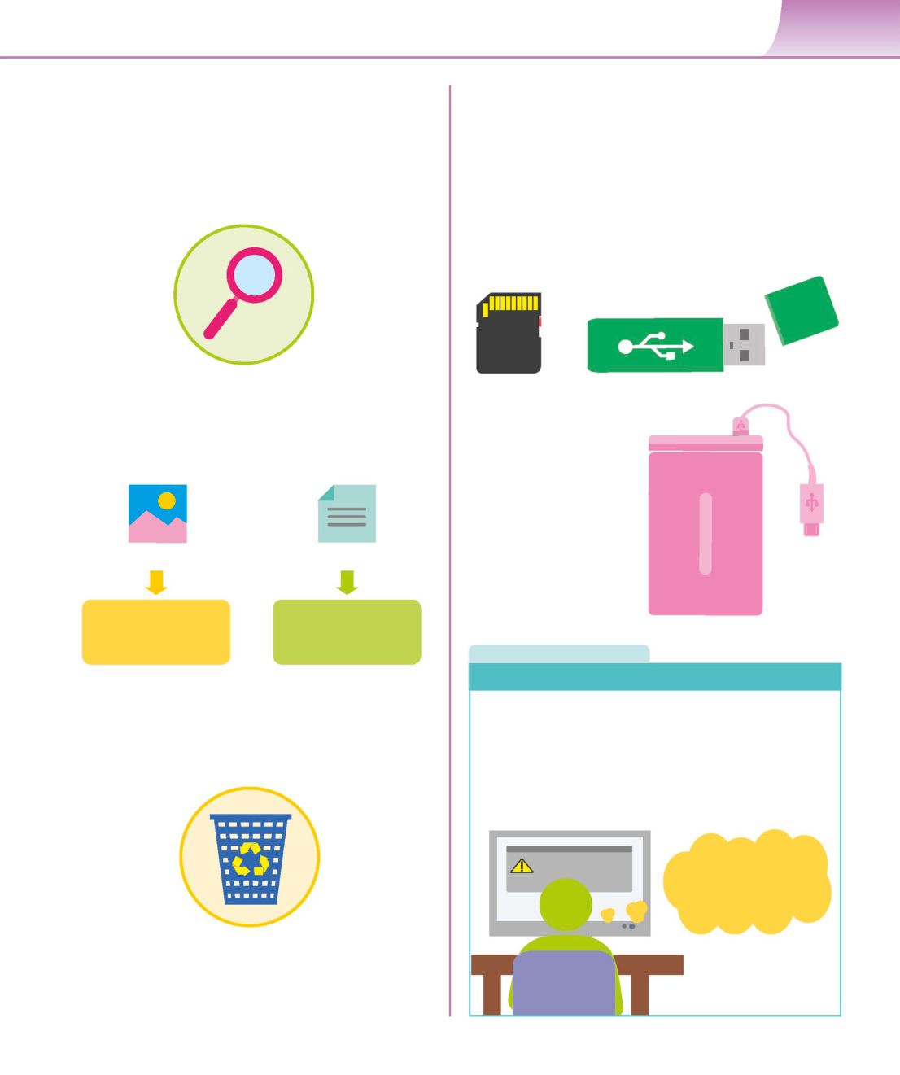

C O M P U T E R S A R E E V E R Y W H E R E **15**

**Looking for files**  **Moving data**

Searching for files on a computer is similar to finding them There are various ways to transfer data between computers.

in a real-world filing cabinet. The file system on a computer Emails can be used to attach pictures, documents, and

is usually accessed using a window containing small icons other files to a message. There are also systems, such as

of folders or documents. A folder can be opened to display Google Drive or Dropbox that allow people to upload

the files inside by touching with a finger on a touchscreen large files and folders to the cloud. These can be shared

or double-clicking with a mouse or trackpad. with others through a link to the uploaded file, which can

then be downloaded, or even edited online.

|  |  |  |
| --- | --- | --- |
| △**Searching for files** | **Secure Digital** | **USB pen drive** |

The best way to look for a file is to find the magnifying **(SD) memory card**

glass icon. Then, click on it and type the filename or

keywords in the search bar.

u **Removable storage**

You can also move files

between computers

through storage devices

such as USB pen drives

|  |  |  |  |
| --- | --- | --- | --- |
| **.jpg** | **.docx** | and removable hard | **Removable** |
| drives. Data can be stored | **hard drive** |

on memory cards, which

can be plugged into

|  |  |  |
| --- | --- | --- |
| **Image** | **Text** | computers to be read. |

|  |  |  |
| --- | --- | --- |
| **viewer** | **viewer** | **R E A L W O R L D** |

**Saving and backing up**

△**Opening files**

A filename usually includes a full stop followed by some letters. Computers and applications can crash without warning. To

This is the file extension, which identifies the type of file and tells avoid losing important work, it’s good practice to save a file

the computer what kind of program it should use to open it. frequently while working on it. It’s also useful to back up files   
 using either a separate hard disk or an online backup service.   
 These services are a part of cloud computing, where people   
 use the storage facilities of a specialist provider to save data.

System crash

**At least my data is saved**

**on the cloud!**

△**In the bin**

Deleting a file by mistake is quite common.   
Deleted files usually go into the recycle or trash   
bin, and can be restored by opening the bin   
and taking the file out.



**16**  **G E T T I N G S TA R T E D**

|  |  |  |
| --- | --- | --- |
| Computing for you | **SEE ALSO**  **‹14–15** Computers are everywhere | |
| Operating systems | **44–45›** |

|  |  |  |
| --- | --- | --- |
| **Software is programs that allow people to use a computer’s** | Desktop computers and laptops | **50–51›** |

**hardware. Most computers come with pre-installed software,**

**but additional pieces of software are also widely available.**

**System software**

System software allows user applications to run on the computer’s hardware.

The operating system (OS) – which controls the computer’s basic functions – ▽**Different operating systems**

is the most common example. It makes the computer work by displaying There are many operating systems available.

information on the screen and getting user input from the keyboard, Microsoft Windows and Linux are the most

touchscreen, or mouse. For computer security, it’s important to install any commonly used ones. Apple machines use

updates that become available for the OS. a specific operating system, called macOS.

|  |  |  |
| --- | --- | --- |
| **Windows** | **Linux** | **macOS** |

**Application software**  **I N D E P T H**

|  |  |
| --- | --- |
| Application software is designed to complete specific tasks on a  computer. Some of these are paid, as either a one-off purchase or | **Icons** |

a monthly subscription. Others may be free to download and use.

Small symbols representing applications   
A lot of free software is also open source, which enables users to   
 or functions on a computer are called icons.

see and modify the application’s code.

They make it easier for people to use their   
computer. Many functions are symbolized

by similar icons across different operating

systems – for instance, a floppy disk   
denoting the save option, or a magnifying   
glass symbolizing the search option.

**Save**  **Volume**

**Email**  **Banking**

△**Different platforms**   
Application software is available for different types of device.

Those used for mobile phones and tablets are usually known

|  |  |  |
| --- | --- | --- |
| as apps. Apps can perform a variety of tasks, such as sending | **Settings** | **Trash** |

emails, social networking, and even banking.



C O M P U T I N G F O R Y O U **17**

**Types of application software**

Modern application software comes in a variety of forms. Some popular   
types include software for email, word processing, spreadsheets, databases,   
presentations, desktop publishing, media editing, and graphics creation.   
Applications are sometimes combined into suites, or sets of interconnected   
and related programs. Many applications allow users to track changes to   
documents made by themselves or colleagues.

|  |  |  |  |  |
| --- | --- | --- | --- | --- |
| **A** | **B** | **C** | **D** | **E** |

|  |  |  |  |
| --- | --- | --- | --- |
| **1** | **Month** | **Income** | **Expenses** |

|  |  |  |  |
| --- | --- | --- | --- |
| **2** | **Jan** | **10000** | **8582** |

|  |  |  |  |
| --- | --- | --- | --- |
| **3** | **Feb** | **12000** | **9464** |

|  |  |  |  |
| --- | --- | --- | --- |
| **4** | **March** | **11000** | **9200** |

|  |  |  |  |
| --- | --- | --- | --- |
| **5** | **April** | **12000** | **9500** |

|  |  |  |  |
| --- | --- | --- | --- |
| **6** | **May** | **10000** | **8580** |

**7**

|  |  |  |  |
| --- | --- | --- | --- |
| **8** | **Sum** | **55000** | **45326** |

**9**

△**Words** △**Numbers**

Word processors are one of the most widely used applications. Spreadsheets allow users to work with numbers and

They can be used to create many styles of document, from a other data, applying mathematical and statistical

simple letter or business contract, to a complex report or even formulae. They can be used for simple tasks, such as

a whole book. A very simple version of a word processor is called basic accounts, and also for complex analyses of data.

a text editor, but this is solely for text and can’t handle images.

△**Images** △**Videos**

With the spread of digital cameras, many people use Video applications allow users to adjust and improve lighting

computers to organize and edit pictures. Photo editing and colour, and add special effects. They can also edit video

applications allow users to modify their pictures – for clips, combine clips into longer videos, and add titles and

instance, by altering the lighting and colour. transitions – such as crossfades – between scenes.

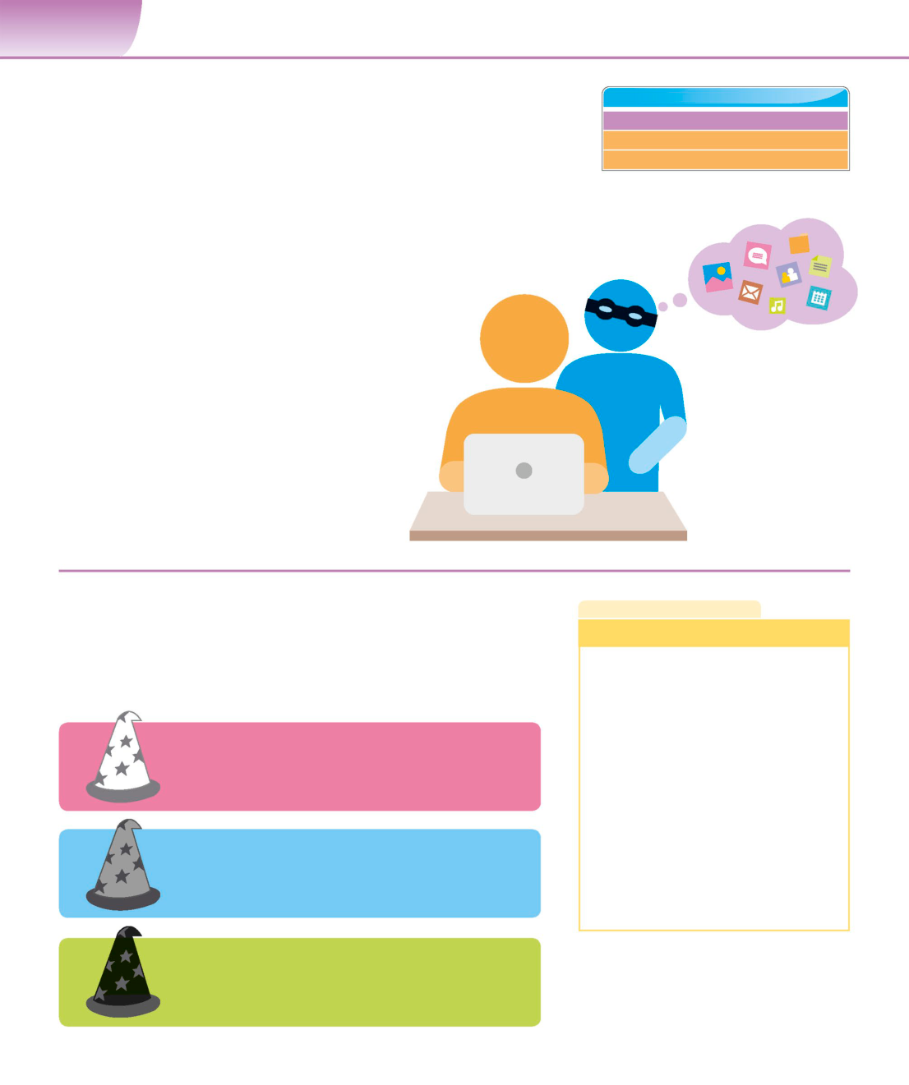

**22**  **G E T T I N G S TA R T E D**

|  |  |  |
| --- | --- | --- |
| Cybersecurity | **SEE ALSO** | **156–157›** |
| Malware |
| Staying safe online | **186–187›** |

|  |  |  |
| --- | --- | --- |
| **Cybersecurity is an issue that’s often in the news.** | Hacking and privacy | **190–191›** |

**Exactly what is it though? And how can computer**

**users protect themselves and their data?**

**What is cybersecurity?**

Cybersecurity is the protection of computers and   
data from attacks by malicious individuals on the   
internet. Attacks can include stealing data, such as   
a person’s banking details, or infecting computers

with viruses that lock users out of their machine. In

organizations where physical systems are controlled

Hackers can steal

by computers, it’s even possible for cyber attacks to all kinds of data if

cause physical damage to equipment. they gain access

to a computer.

▷**User behaviour**

Effective security depends on user behaviour as

well as technical safeguards. Social engineering,   
where hackers use psychological tricks and insights   
to deceive people and gain access to computer   
systems, is a very successful technique.

**Hacked computers**  **L I N G O**

Once a hacker gains access to a computer, there are many ways to harm its **Hacking methods**

|  |  |
| --- | --- |
| owner, their family, or colleagues. Computers contains a lot of information  its owner would not want others to have. Data such as passwords, documents,  emails, and photographs can all be copied and used for criminal purposes. | **Brute-force attack**: trying all possible  password values to find one that works |

**Distributed Denial of Service (DDoS)**:

overloading a website with fake traffic

**White hat**  so that it becomes unavailable

|  |  |
| --- | --- |
| These hackers use their skills to help people. They obtain  permission to hack into systems to identify weaknesses | **Keylogger**: a program that secretly records |

for the owners. every key pressed by a user

**Phishing**: impersonating a website via

email to get users to reveal login details

|  |  |
| --- | --- |
| **Grey hat**  These hackers hack into systems without permission,  which is a crime, but subsequently tell the system owners | **Social engineering**: manipulating  someone to gain access to their data |

about any flaws they find. **Virus**: a malicious program that spreads

to other computers by replication

**Black hat**

Black hat hackers hack into systems without permission ◁**Types of hacker**

in order to steal data or cause disruption to the system’s Hackers are often described in terms of hat

operation and its owners. colours. This comes from cowboy films where

heroes wore white hats and villains wore black.

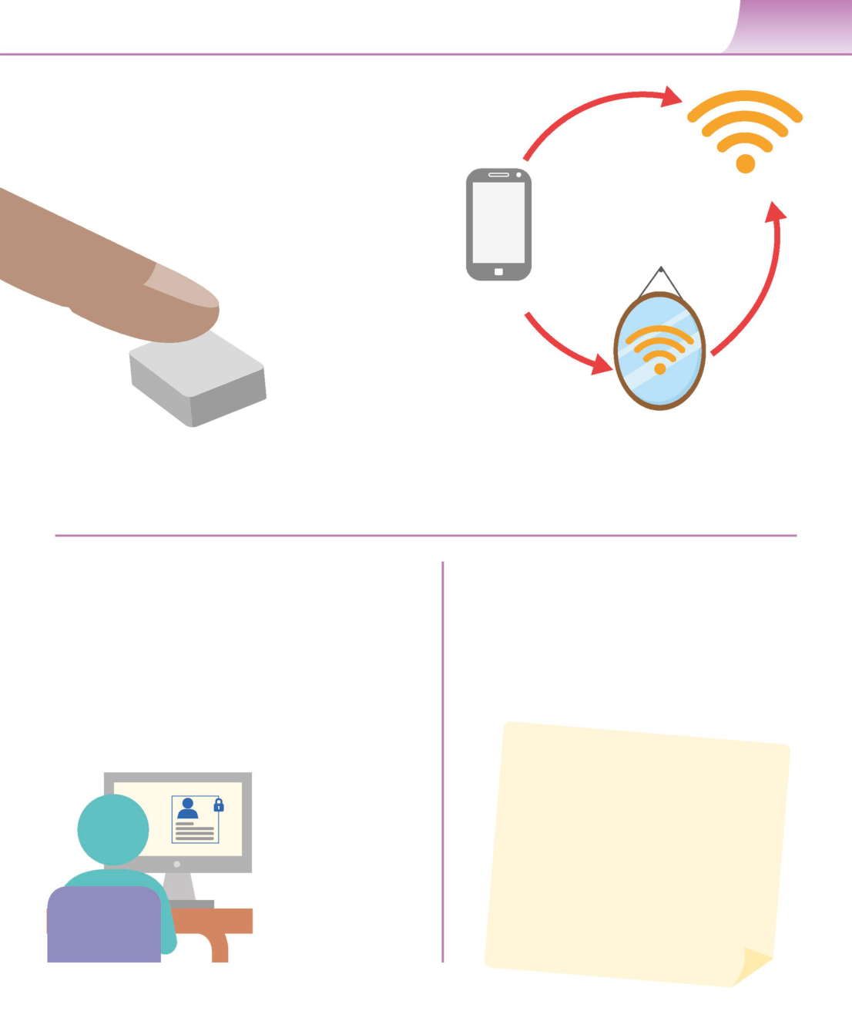

C Y B E R S E C U R I T Y **23**

**Stealing data**

Data is valuable, particularly personal information or The user would

financial data. There are a number of methods hackers normally connect to   
 the internet directly.

can use to compromise devices in order to steal data.

Many of these can be done remotely, or some time

prior to someone using the device.

**Wi-Fi hotspot**

With a keystroke logger

a hacker can read

everything typed,   
including any passwords.   
 **Device connecting to Wi-Fi**

The mirroring device looks and   
acts just like the regular hotspot,   
but the hacker can see everything   
people connected to it do online.

**Wi-Fi mirror**

u **Keyloggers**  u **Wi-Fi mirror**

Keystroke loggers are programs that silently store every key Hackers can use Wi-Fi mirroring devices that mimic public   
pressed on the computer they’re installed on. They are often Wi-Fi hotspots. Instead of connecting directly to the hotspot,   
used to steal users’passwords and bank details. Both software unsuspecting users connect to the mirror device, and as they   
and hardware keystroke loggers exist. browse online, the hacker can see what they do.

**Staying safe from scammers**  **Hazards and good practices**

Scammers try to gain access to people’s money via email. It’s While the presence of malware may make the internet   
wise not to click on any links or open any attachments in emails seem very dangerous, there are simple ways of making   
from strangers. In phishing attacks, the scammers try to imitate your information safer. Installing or activating firewall and   
an email from a bank or other organization in order to get anti-virus software to scan network traffic for suspicious   
people to give up details such as PIN numbers or passwords. packets is a good first step. Downloading and installing a   
Banks and other legitimate organizations will never ask for password manager means passwords for multiple sites can   
security details via email in this way. be stored and operated using only one master password.

Hackers can even target

social media accounts.

◁**Social media**

Hackers can compromise

social media accounts.

Changing the password for   
that site will usually fix this.

However, contacting the   
site’s support team will be   
necessary if a hacker   
changes a user’s password.

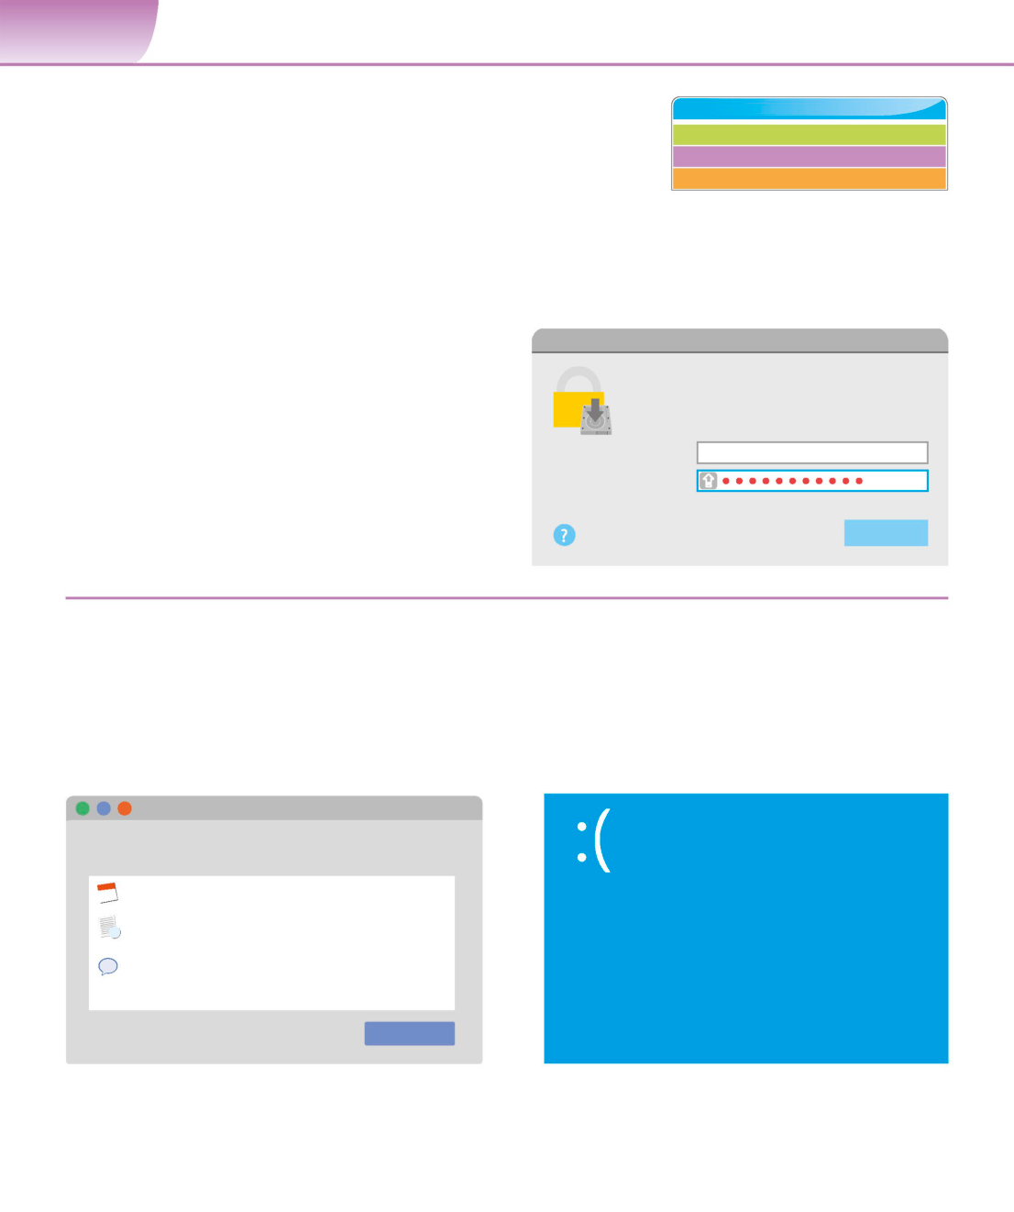

**24**  **G E T T I N G S TA R T E D**

|  |  |  |
| --- | --- | --- |
| Fixing | **SEE ALSO** | **36–37›** |
| Peripheral devices |
| common problems | Connections | **148–149›** |
| Staying safe online | **186–187›** |

**Computer glitches are common and most can be fixed easily and**   
**quickly. This is known as troubleshooting. Advice can be found**   
**online, or from local computer stores or technicians.**

**Difficulty logging in**

Problems with logging in to a computer can be caused by   
having pressed the caps lock key, or accidentally trying to **The username or password you entered**

log in to another user’s account. Forgotten logins can be **is incorrect.**

fixed by using the administrator account to reset the login,

|  |  |  |
| --- | --- | --- |
| or by using a password reset disk. | **Username** | Chris_William |

▷**Locked out**  **Password**

Dealing with a forgotten password can be

|  |  |  |
| --- | --- | --- |
| tricky. If the solutions above don’t work, | **Forgotten password?** | **Log in** |
| seeking advice from a local computer |

technician is the best plan.

|  |  |
| --- | --- |
| **Simple problems**  A very common issue is the computer freezing or failing to  respond to a mouse or keyboard input. This can usually be | “…there is a **solution** to every **problem**.  It may take you a while, but eventually |

|  |  |
| --- | --- |
| fixed by shutting down the machine by pressing the power  button for several seconds and then restarting it again.  Avoid simply switching off at the mains as this can make | you’re going to **find it**.”  **Tony Cardenas (b. 1953), American politician** |

matters worse.

**Force Quit Applications**

**If an app doesn’t respond for a while, select its**

**name and click Force Quit.**

Calendar

**Your PC ran into a problem that it couldn’t**

**handle, and now it needs to restart.**

Notes

Messages

You can search for the error online: HAL

_INITIALIZATION_FAILED

|  |  |
| --- | --- |
| You can open this window by pressing  Command-Option-Escape | **Force Quit** |

△**Task Manager** △**Blue Screen of Death**

If a particular program isn’t responding, hold down Windows shows the“Blue Screen of Death”when a

the ctrl, alt, and delete keys on a computer running serious fault occurs. After restarting, the computer

Windows or cmd, option, and escape keys on a Mac. should be able to guide users towards a solution.

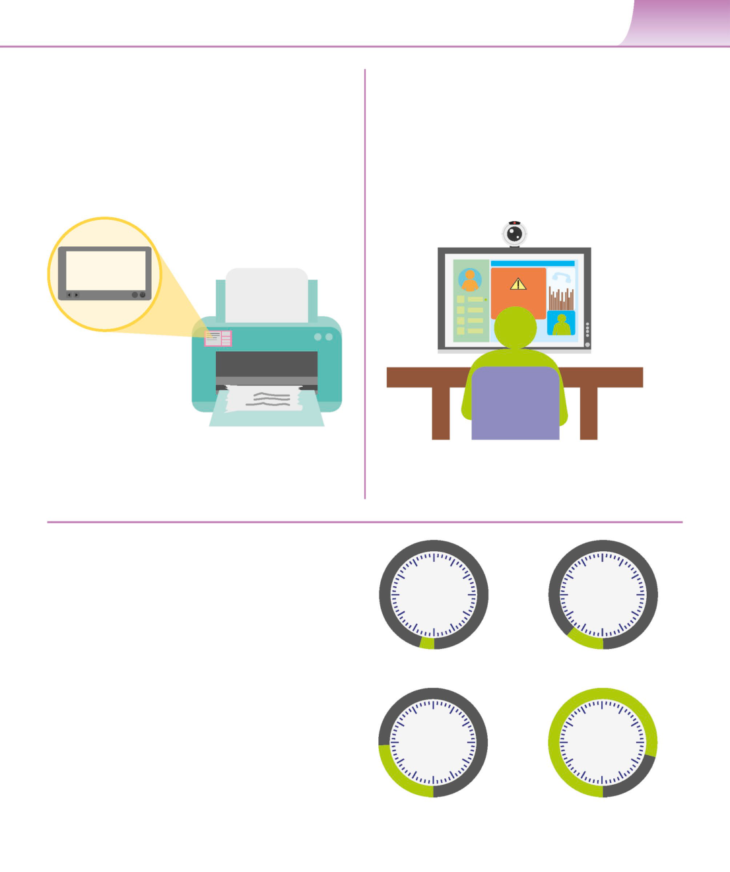

F I X I N G C O M M O N P R O B L E M S **25**

**Printers**  **Sound and webcams**

Printer problems are often caused by a lack of paper or Problems with sound and webcams can be frustrating,   
paper jams. Most printers have warning lights and displays particularly for users trying to take part in online meetings.

to indicate these issues. Another possible issue is low ink Checking the computer’s settings for sound output and   
or toner levels. Opening the printer settings in the Control input might help to solve the problem. Forgetting that   
Panel in Windows, or System Preferences on a Mac will headphones are plugged in can also be the source of   
reveal more specific error messages. missing sound. Some computers and headphones have   
 built-in microphones, but a computer may still need an   
 external microphone to be plugged in.

Most printers display

error messages

or symbols.

No sound could

**Paper Jam**  be down to the

computer being   
muted, or the   
sound settings   
not being set   
up properly.

△**Quality issues**   
Bad quality printing can be caused by badly △**Webcam connectivity**

aligned or clogged print heads. Printers usually People often cover the webcam when not in use

come with software that allows users to to protect against hackers. If so, it’s important to   
diagnose and fix these types of issue. remember to uncover it before use.

**Wi-Fi and data**

Wi-Fi connections can sometimes be temperamental.

|  |  |  |
| --- | --- | --- |
| Check that the computer is actually connecting to the | **1MB** | **25MB** |
| correct Wi-Fi and not a neighbouring one with a weaker |

signal. If there seems to be no signal at all, try switching

the router off for a few seconds and then turn it back

on. If a Wi-Fi connection seems slow, there are speed-test

|  |  |  |
| --- | --- | --- |
| websites online that can determine the current speed. | **Viewinganemailwith** | **Browsing for an hour** |
| Aslowconnectionisusuallyshort-livedandmostly | **an attached picture** |

due to issues with the internet provider, possibly

affecting many users in a local area.

**150MB**  **2GB**

▷**Data usage**   
Some internet providers, and many mobile   
phone contracts, limit the amount of data

customers can use each month. It therefore

|  |  |  |
| --- | --- | --- |
| is useful to know how much data different | **Downloading music** | **Streaming HD videos** |

|  |  |  |
| --- | --- | --- |
| online activities use. | **for an hour** | **for an hour** |

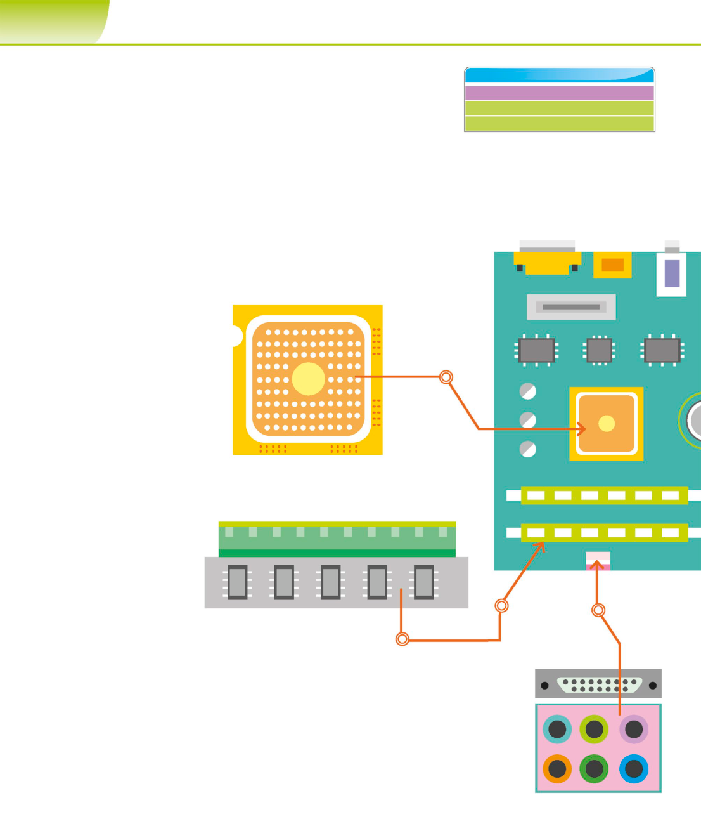

**34**  **W H AT I S C O M P U T E R S C I E N C E ?**

|  |  |  |
| --- | --- | --- |
| Inside a computer | **SEE ALSO**  **‹14–15** Computers are everywhere | |
| Peripheral devices | **36–37›** |

|  |  |  |
| --- | --- | --- |
| **Under the casing, a computer’s hardware is a host of electronic** | Processing and memory | **42–43›** |

**circuitry, components, and connections. As they become ever**

**more powerful, their components need to be smaller, use less**

**power, and generate less heat.**

|  |  |
| --- | --- |
| **Components of a computer** | The motherboard connects  either directly or indirectly to |

The components inside a computer are fairly similar, regardless every part of the computer.

of the type of computer it is. The parts may look a bit different,

but they fulfil the same functions. Understanding what the various   
parts do and how they work can help users troubleshoot problems   
or decide whether it is time to upgrade their hardware.

The CPU is a ceramic

square with a silicon

▷**Central processing unit**  chip located inside.

The central processing unit (CPU),   
also known as a microprocessor, acts   
as the brain of the computer. It controls   
most of the machine’s operations and

carries out commands. Instructions

are sent to the CPU by pressing a key,   
clicking the mouse, or starting an   
application, or file.

The RAM is slotted into a reader on the   
 motherboard. RAM can be removed and  
▷**RAM**  upgraded if more is needed.

This is the system’s short-term   
memory. Whenever a computer   
performs calculations, it   
temporarily stores the data in   
the random-access memory

(RAM) until it is needed. The

data on the RAM is cleared when

the computer is turned off.

Ports are   
colour-coded for   
clear identification.

“...**computers** have become the most

|  |  |
| --- | --- |
| **empowering tool** we’ve ever created. They’re tools of **communication**, | ▷**Ports**  Computers have an array of ports that  allow users to connect external devices to |

|  |  |
| --- | --- |
| they’re tools of **creativity**, and | the motherboard. Common ports include  universal serial bus (USB), Ethernet (used |

|  |  |
| --- | --- |
| they can be **shaped** by their **user**.”  **Bill Gates (b. 1955), American co-founder** | to connect computers together to form  a network), video-graphic array (VGA),  high-definition multimedia interface |

**of Microsoft**  (HDMI), and ports for headphones

and microphones.

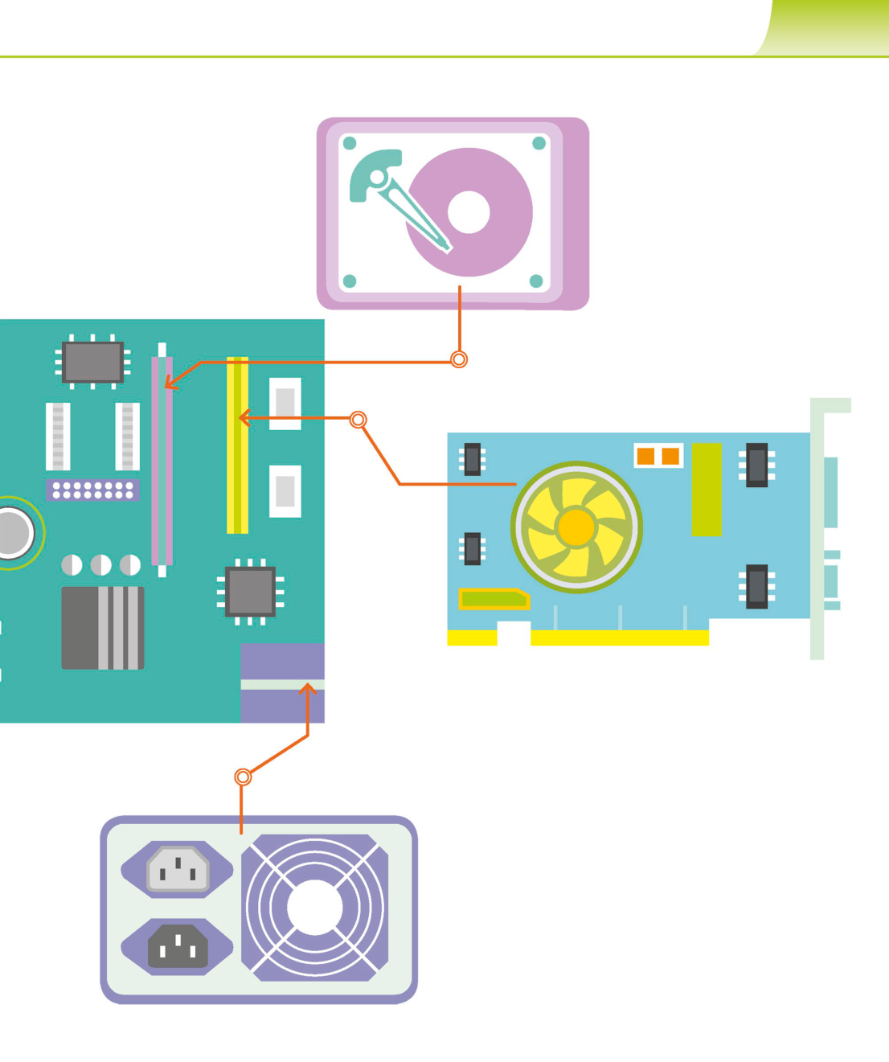

I N S I D E A C O M P U T E R **35**

▽**Motherboard**

The computer’s main circuit board is

called the motherboard. It allows the ◁**Hard drive**

other components to communicate A computer’s software, documents,

with each other. The motherboard is and other files are stored on its hard

a thin plate that holds the CPU, drive as binary code. It holds data,   
memory, connectors for the hard even if the computer is switched off

drive and optical drive, expansion or unplugged. The quicker the hard

cards to control the video and audio, drive, the faster the computer can   
and connections to a computer’s start up and load programs.

ports. It holds all the circuitry that   
ties the functions of the computer   
components together.

A computer system generally

has between one and

seven expansion slots.

Chips provide extra △**Expansion slots**

processing power These slots allow the user to add various types of

for specific parts of   
 expansion card, which help to boost or update the

the computer.

performance of a computer. Expansion cards can   
upgrade the sound or video, or enable the computer

to connect to networks or Bluetooth.

◁**Power unit**

This converts the power from the wall outlet   
to the type of power needed by the computer. Power is   
sent to the motherboard and other components through   
cables. The power unit also regulates overheating by   
controlling voltage, which may change automatically   
or manually depending on the power supply.

Power units usually have a   
fan that stops the computer’s   
components from overheating.

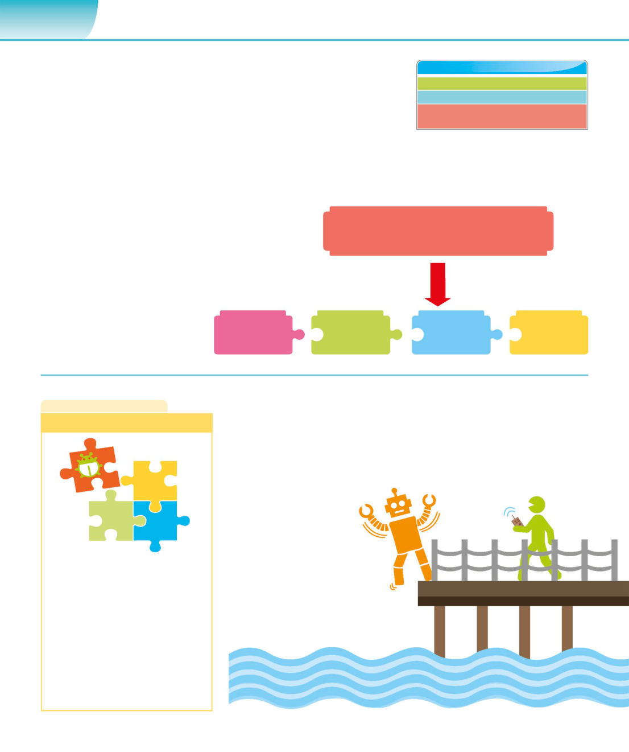

**70**  **C O M P U TAT I O N A L T H I N K I N G**

|  |  |
| --- | --- |
| Decomposition | **SEE ALSO**  **‹28–29** Computer science  **‹68–69** What is computational thinking? |

|  |  |  |
| --- | --- | --- |
| **Decomposition doesn’t sound like the sort of thing anyone would** | What do programming | **118–119›** |
| **want happening near a computer. Luckily, this decomposition is** | languagesdo? |

**actually the first step in the computational thinking process.**

**What is decomposition?**

Decomposition is the process of breaking down

problems into smaller components. An effective tool

|  |  |
| --- | --- |
| in computational thinking, it allows programmers to  build effective solutions. When an apple decomposes,  it’s breaking down into simpler chemicals that other | **PROBLEM** |

plants can use as food. In a similar way, a problem   
can be solved by splitting it into smaller parts that   
a programmer already knows how to tackle.

|  |  |  |  |  |
| --- | --- | --- | --- | --- |
| ▷**Find the sub-problems** | **P** | **RO** | **BL** | **EM** |
| A lot of everyday problems are |
| actually made up of smaller parts, |

which we can call sub-problems.

**L I N G O**  **Computer sense**

|  |  |
| --- | --- |
| **Modular code** | Computers, unlike people, don’t have any common sense or knowledge  of how things work. They do exactly what they’re told to do, even if the |

instructions are ridiculous or totally wrong. When writing a program for a   
computer to solve a problem, computer scientists must include precise   
and detailed instructions on how to do each tiny step.

Building a program by writing small   
amounts of code to solve sub-problems ▷**Task gone wrong**

is known as a modular approach. If If a computer is given instructions

there is a problem with a part of the that are inaccurate, in the wrong

code, it can easily be taken out and order, or incomplete, it won’t

fixed. Each smaller solution is tested complete the task successfully.

before it’s added to the main program.

Breaking the original problem into   
sub-problems also gives programmers   
the option of sharing the work

among a team.

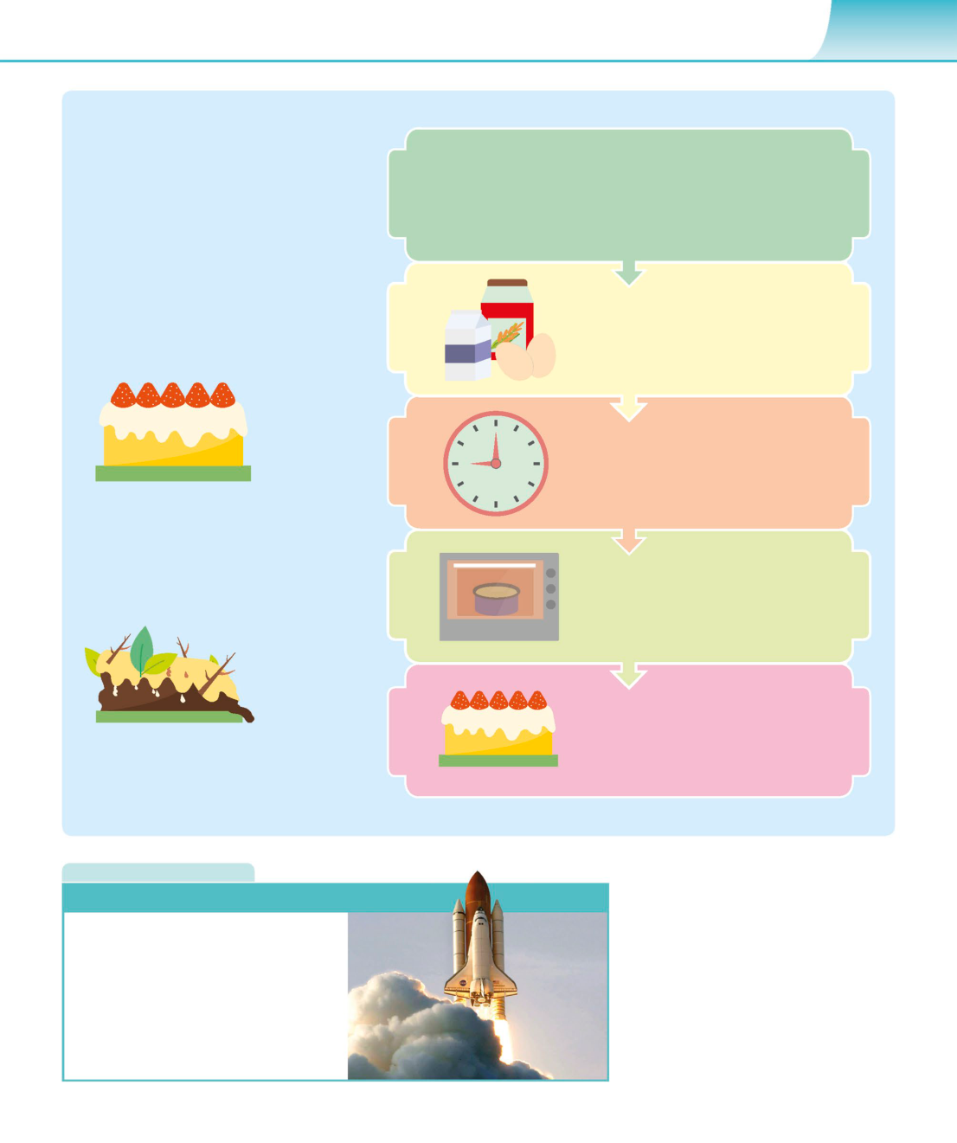

D E C O M P O S I T I O N **71**

**Decomposition in action**

Decomposition is a lot like baking a

cake. Both involve a task and some **Important parts**

tools. In baking, the task is to make Breaking down a problem into smaller parts

a cake, and the tools are the bowl, helps find an effective solution. Each part

spoon, oven, and ingredients. In must then be completed successfully and in

the right order to get the required result.

computing, the task might be to

write a program, and the tools are a

computer and programming language.

A good way to start is to look at the **Ingredients and preparation**   
problem in more detail and break it To bake a cake, the first step is to buy or

down into smaller tasks.

gather the ingredients. The right amount of   
each ingredient must then be prepared while   
the oven heats up to the correct temperature.

**Timing and combining**   
Each ingredient must be added and   
combined at the right time before the   
mixture is put in the oven.

△**Getting it right**   
Breaking down the steps and then   
successfully completing each one   
will result in getting the cake right. **Baking**   
In computer science, it’s important The next step is to ensure that the   
to know what the objective is before mixture is baked at the right   
beginning to write code. temperature and for the   
 required amount of time.

**Finishing**   
Finally, the cake must be removed

|  |  |
| --- | --- |
| △**Getting it wrong** | from the tray and allowed to cool.  It can then be decorated so that it |

Not working in a step-by-step manner both looks and tastes nice.   
to bake a cake or build a solution will

result in failure.

**R E A L W O R L D**

**Building a spaceship**

We often solve a

No matter how complex a computer   
program is, it’s made up of solutions **problem** by **breaking** it

|  |  |
| --- | --- |
| to lots of tiny problems. The process  of building a complicated model of | down into **smaller parts**. |

a spaceship out of building blocks is   
similar. Each part is the solution to   
a sub-problem and combining the   
components creates the spaceship.

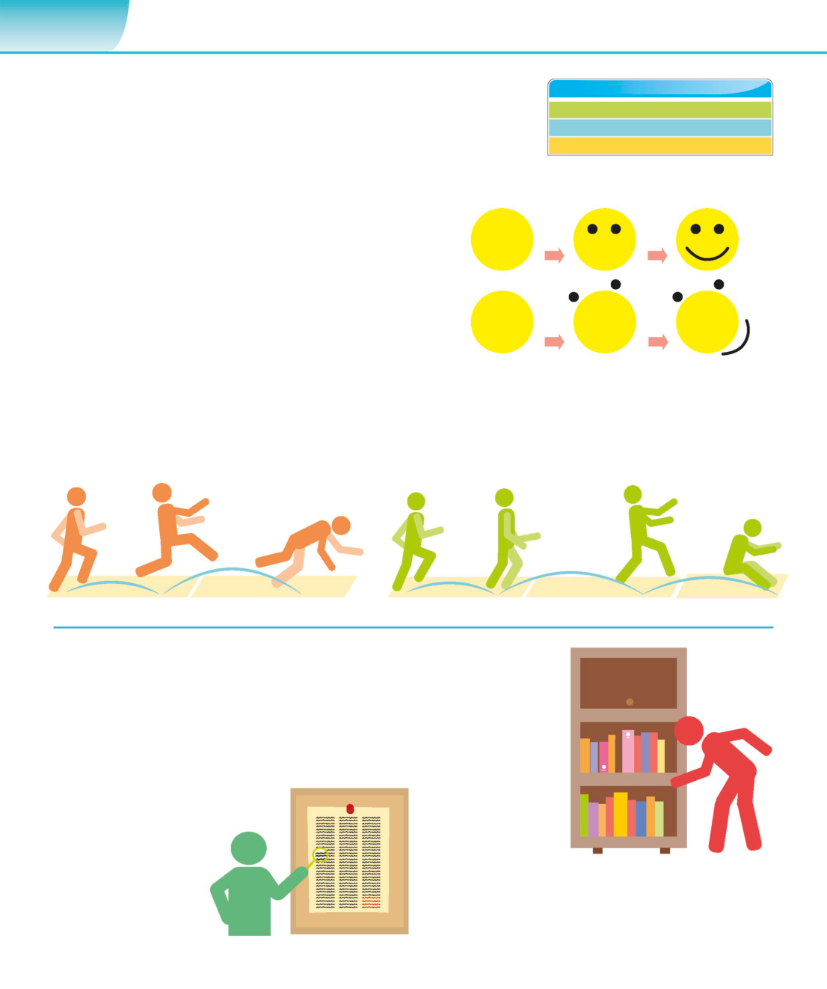

**76**  **C O M P U TAT I O N A L T H I N K I N G**

|  |  |
| --- | --- |
| Algorithms | **SEE ALSO**  **‹30–31** Computing before computers  **‹68–69** What is computational thinking? |

|  |  |  |
| --- | --- | --- |
| **Though the word itself might sound unfamiliar, we all use** | Applying algorithms | **102–103›** |

**algorithms every day. Baking a cake, knitting a jumper, or putting**

**together a piece of furniture are all activities that use algorithms.**

**What is an algorithm?**

An algorithm is a series of steps to solve a problem or carry out a   
task. To develop an algorithm, start by using decomposition to   
break down the problem into smaller tasks, then look for patterns   
in these tasks, and finally ignore unimportant details. This should   
give you the information you need to create an algorithm made of   
small steps that can all be described very clearly.

△**Unambiguous**  
**Step by step**

Each step in an algorithm must be precise and unambiguous,   
Algorithms describe a series of steps that must happen

with only one possible meaning. Vague instructions give   
in sequence in order for the problem to be solved. In

incorrect results. An algorithm for drawing a smiley face   
athletics, the triple jump competition involves the

might read:“draw a circle, then a curved line, and then two   
competitor running, then performing a hop, a bounce,

dots”. But this doesn’t tell us where the curved line and

and a horizontal jump at specific places in order to

record a successful effort. the dots should go in relation to the circle, or each other.

**H-N**

**Types of algorithm**

Algorithms exist for many different computer tasks: from

|  |  |
| --- | --- |
| smartphone apps that can tell what song is being played  to the algorithms used by online search engines. One area | Rejected Pass 1 |

where algorithms are very influential is data-processing;

in particular, algorithms for searching and sorting data. There

are different kinds of searching and sorting algorithm. Rejected Pass 2

r **Linear search**

To find one item in a Pass 3: book found

million, start at the first

one and see if it’s the right

item. If it is, stop searching; **Binary search**

otherwise, look at the next For data that’s already sorted – for instance, an alphabetical

item. This isn’t efficient as bookshelf – a binary search is efficient. At each stage, you decide   
it might involve looking at which half of the data the item you want is in. The half you don’t   
every item on the list. need is discarded. This is repeated until the item is found.

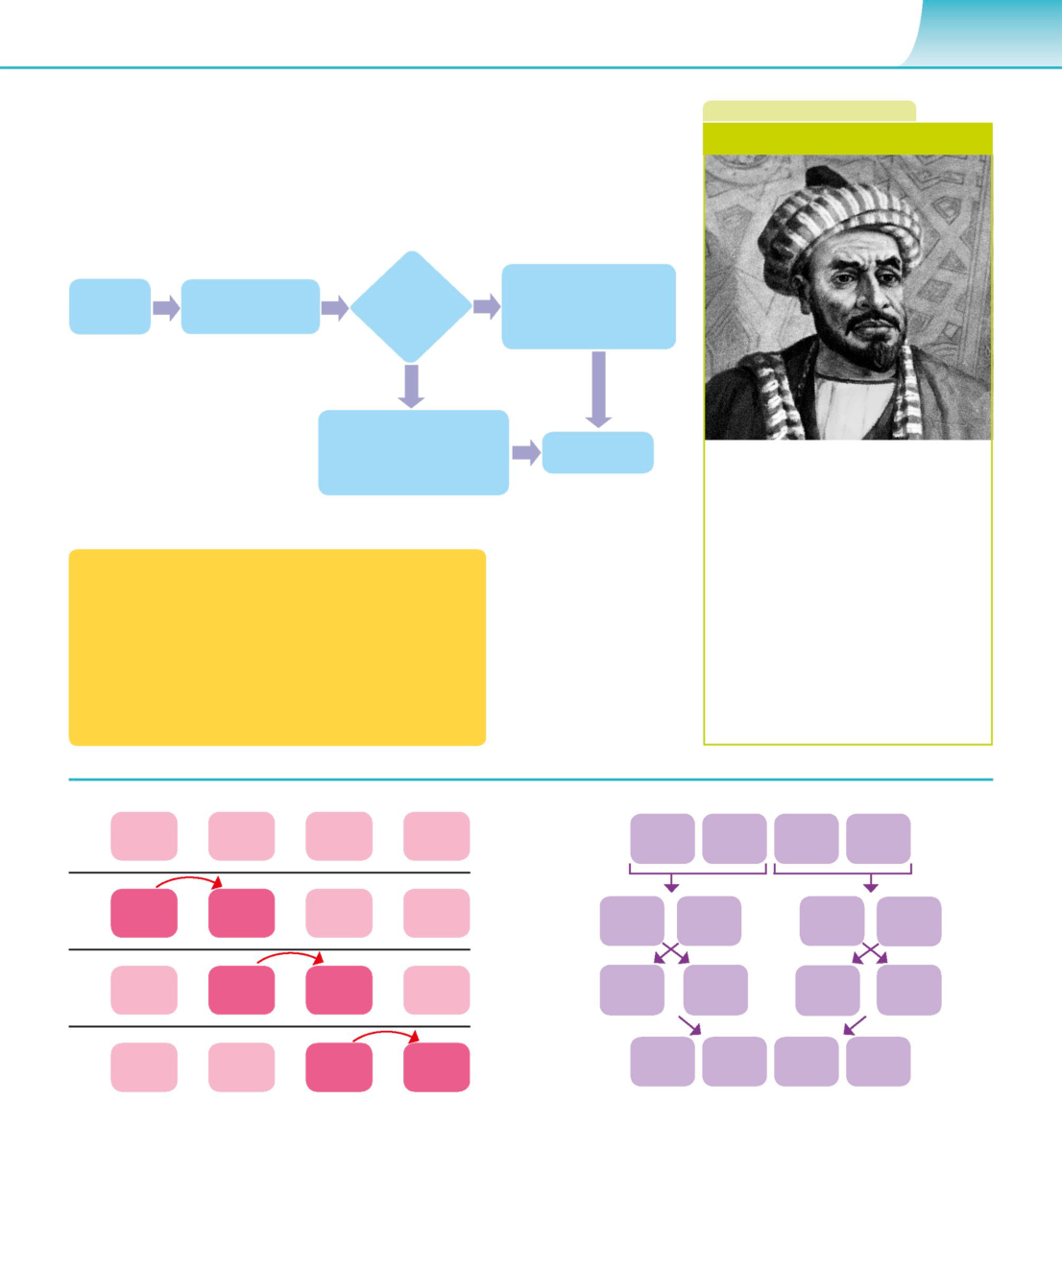

A L G O R I T H M S **77**

**Describing algorithms**  **B I O G R A P H Y**

Algorithms can be described using flowcharts or **Muhammad Al-Khwārizmī**

pseudocode. A flowchart is made up of boxes linked by   
arrows. Each box contains a step in solving the problem   
or a question. Pseudocode is laid out like a computer   
program, but it’s written in a human language.

**No**

|  |  |  |  |
| --- | --- | --- | --- |
| **Start** | **Ask user for age** | **Is age >17** | **Print“you are too** |
| **young to drive now”** |

**Yes**

This is the output of the

|  |  |  |  |
| --- | --- | --- | --- |
| program for people more | **Print“you can apply** | **End** | The word“algorithm”comes from the |
| than 17 years of age. |
| **for a driving licence”** |

name of 9th-century mathematician

Abu Abdullah Muhammad ibn Mūsā

al-Khwārizmī. Al-Khwārizmī lived in

Baghdad, Iraq, and translated a number

|  |  |  |
| --- | --- | --- |
| Ask the user to enter their age in years | ◁**Pseudocode** | of scientific books from ancient Greek |
| and Sanskrit into Arabic. He also wrote |

|  |  |  |
| --- | --- | --- |
| If the user’s age is greater than 17 | Describingalgorithms | several books on mathematics, |
| in pseudocode allows | astronomy, geography, and history. |

|  |  |  |
| --- | --- | --- |
| print “You can apply for a driving licence” | programmers to understand | These books were later translated |

|  |  |  |
| --- | --- | --- |
| else | them, no matter what | into Latin and studied in European |
| computer languages | universities. The word“algebra”comes |

|  |  |  |
| --- | --- | --- |
| print “You are too young to drive just now” | they are familiar with. This | from the title of one of his books. |
| makes the whole range |

of algorithms available.

|  |  |  |  |  |  |  |  |  |
| --- | --- | --- | --- | --- | --- | --- | --- | --- |
| **P1** | **6** | **2** | **4** | **5** | **I** | **E** | **U** | **K** |

|  |  |  |  |  |  |  |  |  |
| --- | --- | --- | --- | --- | --- | --- | --- | --- |
| **P2** | **2** | **6** | **4** | **5** | **I** | **E** | **U** | **K** |

|  |  |  |  |  |  |  |  |  |
| --- | --- | --- | --- | --- | --- | --- | --- | --- |
| **P3** | **2** | **4** | **6** | **5** | **E** | **I** | **K** | **U** |

The final list is

|  |  |  |  |  |  |  |  |  |  |
| --- | --- | --- | --- | --- | --- | --- | --- | --- | --- |
| **P4** | **2** | **4** | **5** | **6** | ordered | **E** | **I** | **K** | **U** |
| alphabetically. |

**Bubble sort** **Merge sort**

This looks at the items a pair at a time, swapping This breaks a list of items into many tiny lists. It then

them round if the second one of the pair is larger merges all these lists into newly sorted ones, finally

than the first. It’s not very efficient as it’s often producing a single sorted list. It uses more code than

necessary to go through the list several times. bubble sort, but is more efficient.

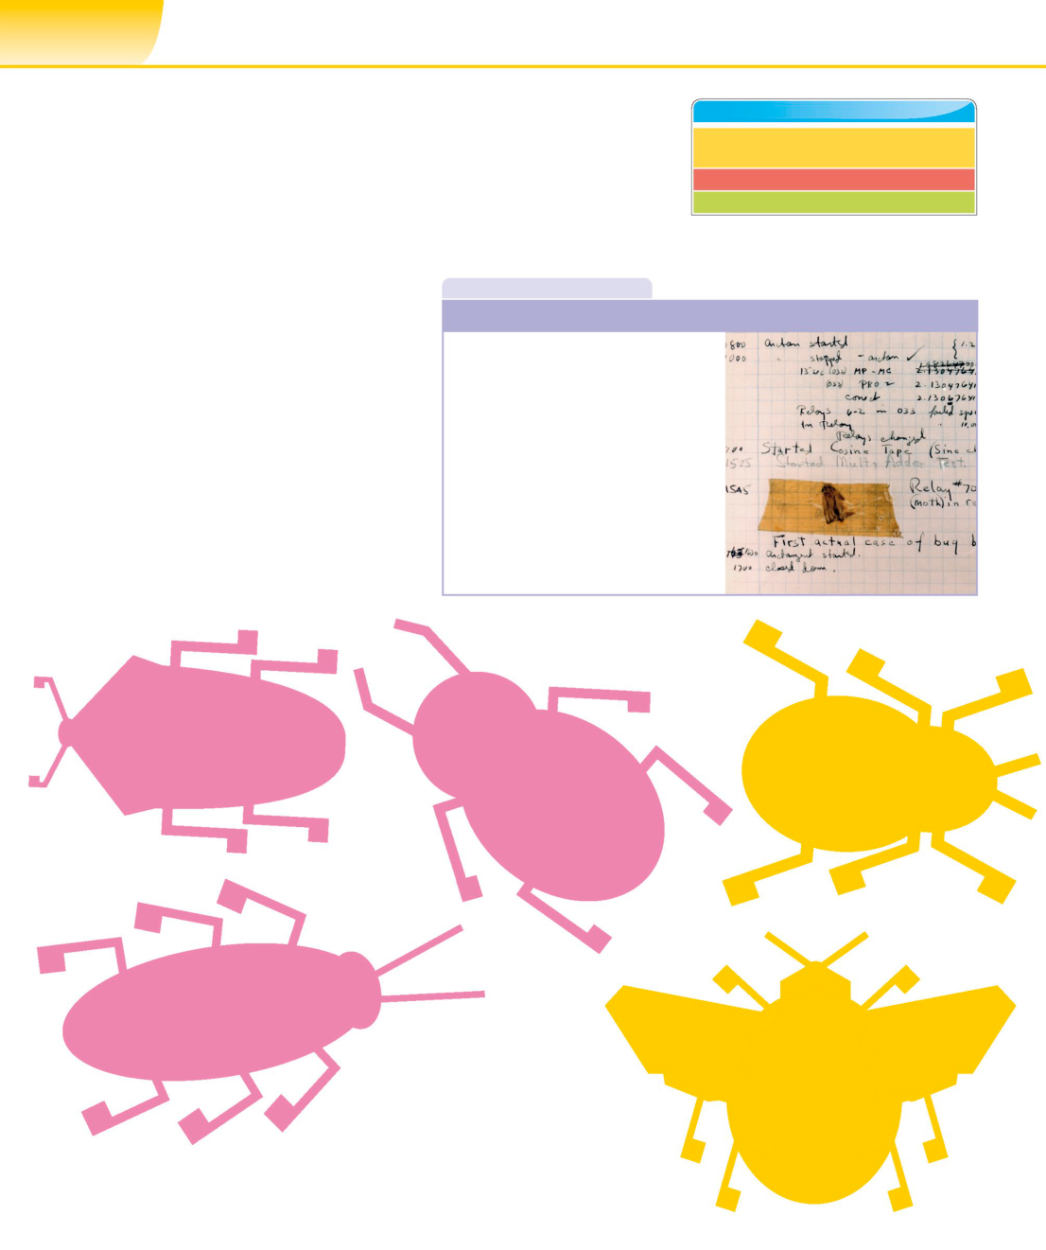

**114**  **P R O G R A M M I N G T E C H N I Q U E S**

|  |  |
| --- | --- |
| Software errors | **SEE ALSO**  **‹112–113** Assemblers, interpreters, |

and compilers

|  |  |  |
| --- | --- | --- |
| **No program is ever entirely error-free. Luckily, there are** | Languagebreakthroughs | **122–123›** |
| Maintenance and support | **174–175›** |
| **many techniques and tools that programmers can use to** |

**detect and fix these errors.**

**Bugs in a program**  **I N D E P T H**

An important part of being a programmer is **First bug**

|  |  |
| --- | --- |
| the ability to recognize software errors, also  called “bugs”, and fix them. There are three  types of bugs – syntax, logic, and runtime  errors. While some bugs cause obvious crashes  and are easy to locate, others are subtle and  can take months to find. | In 1945, computers filled entire rooms  and produced a lot of heat that  attracted bugs, which crawled inside  the machines and caused short circuits.  On 9 September 1945, American |

computer scientist Grace Hopper   
(1906–1992) found that a moth had

caused a malfunction in the Harvard  
▽**Syntax errors**   
A syntax error is a typo or a small mistake, Mark II computer, and she taped the

introduced by a programmer into the wording moth into the computer’s log book.

of the program. The compiler – which translates The term“bug”for a computer problem

programming languages into machine code – has been used ever since.

will not work until all syntax errors are fixed.

▷**Logic errors**

A logic error is a flaw in the program’s

design that causes unanticipated behaviour.   
These bugs can be harder to find as they   
don’t always produce crashes.

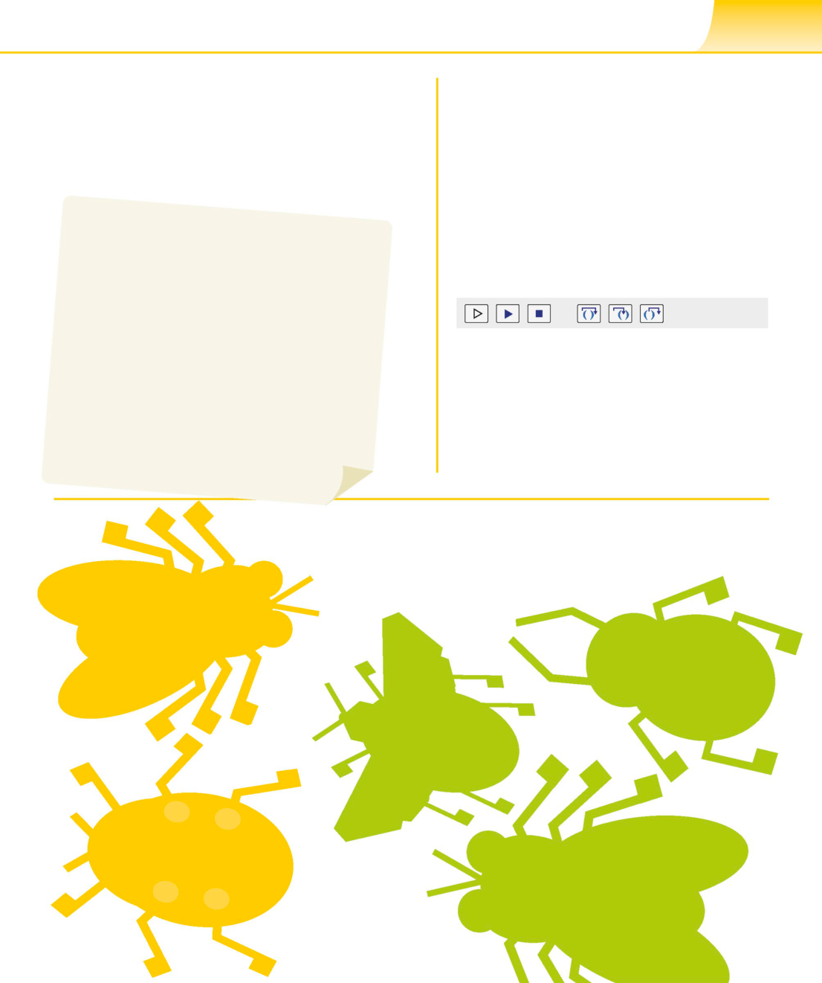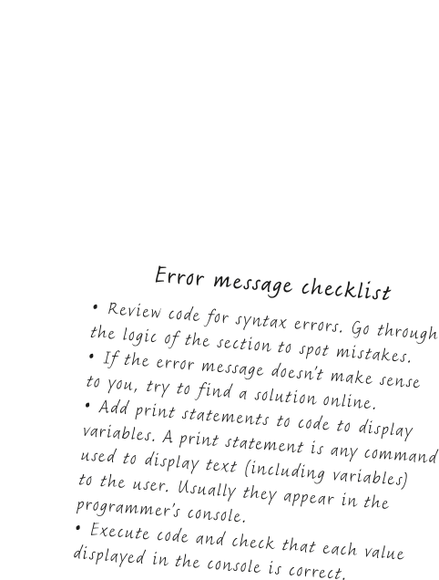

S O F T W A R E E R R O R S **115**

**What to do when an error**  **Debugging**

|  |  |
| --- | --- |
| **message appears**  When an error message appears, the first task for programmers  is to locate the bug. The compiler usually indicates which line of  code caused a crash. However, some errors have a trickle-down  effect and the actual error is several lines higher. | A debugger is a program used to find bugs in other  programs. Most debuggers can run through the script  (the program’s instructions) in a step-by-step mode  to isolate the source of the problem. Some debuggers  can then fix the problem, or offer ways in which this can  be done. The program can then be run again to see if |

the debugger has fixed the problems it found.

Run script Step over

Continue Step out   
debug script

**Status:**

|  |  |  |
| --- | --- | --- |
| Stop script | Step in | Message area |

△**Breakpoints**   
A program freezes when it reaches a breakpoint,   
allowing programmers to detect the errors at   
their leisure. They can also check through the

code one line at a time.

▽**Runtime errors**

A runtime error is a specific type of logic   
error that occurs in the middle of a working   
program and causes it to crash. Usually,   
the program freezes or a pop-up box appears.

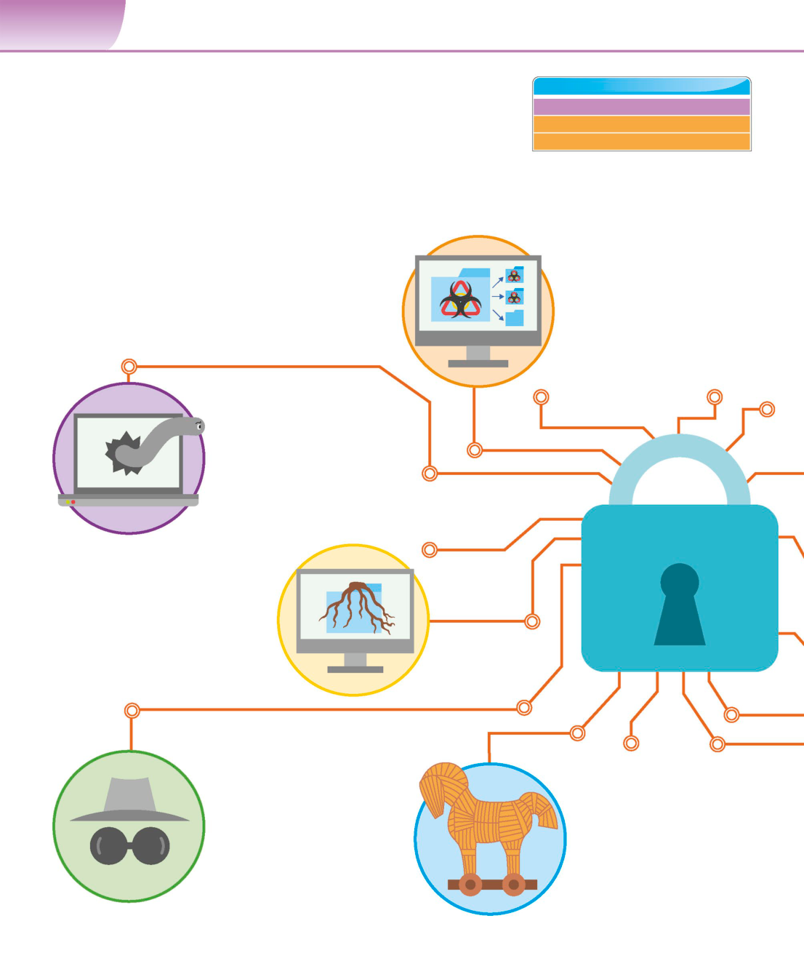

**156**  **N E T W O R K S**

|  |  |
| --- | --- |
| Malware | **SEE ALSO**  **‹22–23** Cybersecurity |

Staying safe online **186–187›**

|  |  |  |
| --- | --- | --- |
| **Malicious software, or malware, is harmful programs that gain** | Hacking and privacy | **190–191›** |

**illegal access to digital devices. They can make their way into a**

**computer or device via email attachments or unprotected websites.**

**Types of malware**

Malware can break into a computer and wreak havoc. These

programs can slow down a device, send spam emails, or ◁**Viruses**

even steal or delete personal data. Malware is classified Viruses are tiny pieces of code that   
based on how it enters the computer, and what it does sneak in by attaching themselves

once it’s there. Here are the different types of malware that to pre-existing files, such as email

can attack a digital device. attachments. The goal of a virus is   
 to spread to as many files on as many   
 systems as possible. They corrupt data   
 and slow down operating systems.

◁**Worms**

Similar to viruses, worms tag along   
with legitimate downloads. They’re   
self-replicating and can spread   
through networks, often via   
automated email spam. Unlike   
viruses, worms are stand-alone

software. They don’t need human   
 triggers and are only installed on   
each computer once.

**Rootkits** ▷

Rootkits hide inside an operating system.   
They gain root (administrator) access to   
 a computer and modify critical files,   
which can lower security and let in other   
 types of malware. As they hide inside   
 operating systems, they are difficult to   
 detect and destroy.

◁**Spyware**   
 Spyware is a general term ◁**Trojans**   
 for any program that tracks Named after the Greek tale of

data without permission. the Trojan Horse, a trojan is a   
Examples include keyloggers malicious program that looks   
(programs that track what keys safe. Once downloaded, the   
are pressed in order to gain trojan installs its payload on

access to passwords and other the computer. This could be a

information) or programs that copy keylogger, a backdoor, or any

browser history and Google searches. number of malicious programs.

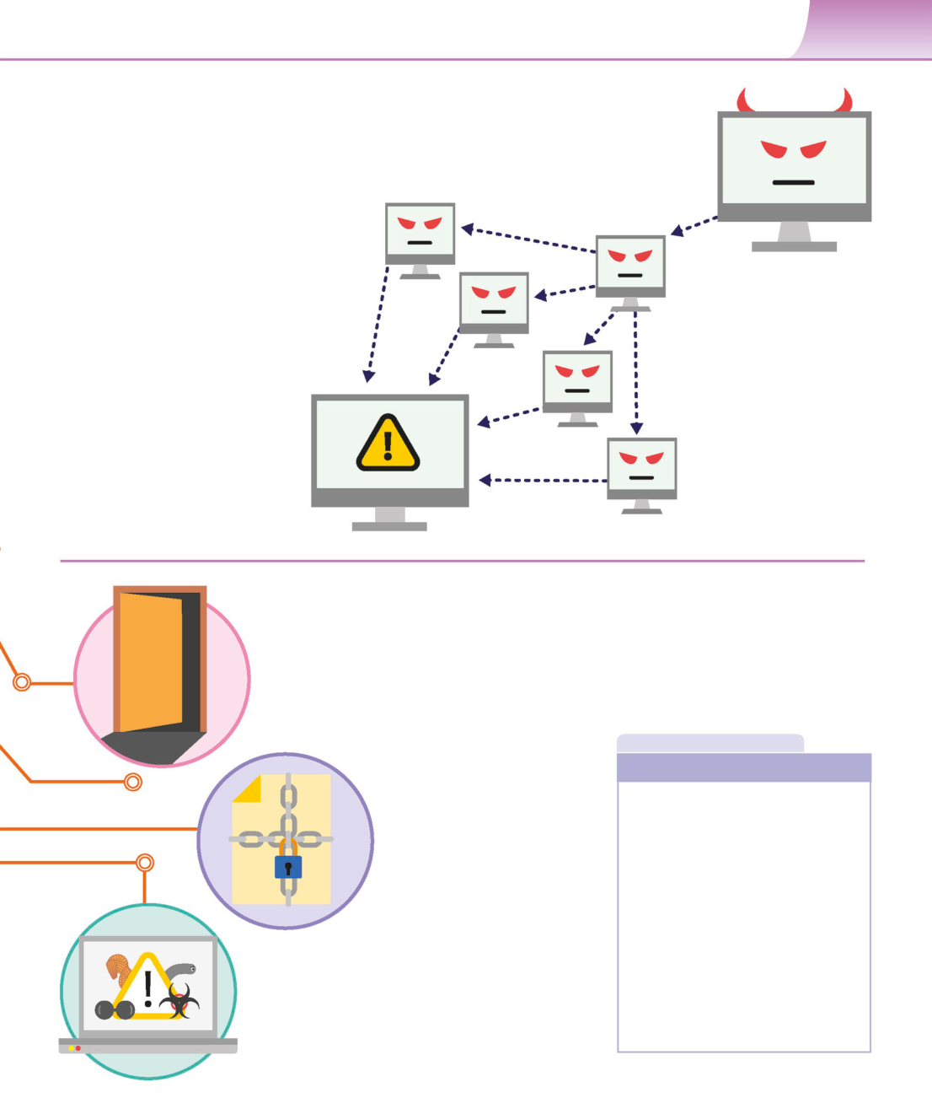

M A L W A R E **157**

**Botnets**

An internet bot is a software application   
that performs automated functions over the Infected computers   
internet. A botnet is a network of bot-infected spread malware.

computers. While the infected computer might   
run normally, there’s software on it that lets a  
“puppet master”hijack the computer. Botnets   
can be used to store illegal content or mount   
cyberattacks without the user’s knowledge.

The botnet’s

originator

Computer

under attack

Bots can be used

▷**DDoS attacks**  for illegal activity.

DDoS stands for Distributed Denial of

Service. A DDoS attack overwhelms a

server by flooding it with data, often

sent by botnets. The server receives   
so many requests that it can’t function   
properly, sometimes causing it to crash.

◁**Backdoors**

A backdoor allows users to bypass all regular   
security checks, such as passwords and   
 permission settings. Sometimes,   
 backdoors are created by accident   
 when developers leave a loophole   
 in the software. Other times, they are   
installed by malicious code.

**I N D E P T H**

◁**Ransomware**  **Cookies**

Ransomware sneaks onto a computer

and encrypts files, effectively holding Cookies are small files stored inside the

them for ransom. Unless attackers browser cache, which is a temporary

are paid, everything on the computer storage location for downloaded files.

is inaccessible. Ransomware uses Websites send cookies to a computer to   
strong encryption protocols. It’s keep track of sessions, making it possible

almost impossible to break the code to log in and out of online accounts.

without paying for access to the key. However, some cookies track activity

across multiple sites. While cookies don’t

contain personal information, hackers

◁**Hybrid threats**  can steal a session by intercepting

Programs that have characteristics of multiple types of them. This could give them access to

malware are called hybrid threats. A worm may drop a virus information, such as credit card details,

on a computer, or it may behave like a trojan. Classification stored on a user’s account.

provides a starting point for identification and defence, but

each threat must be neutralized individually.

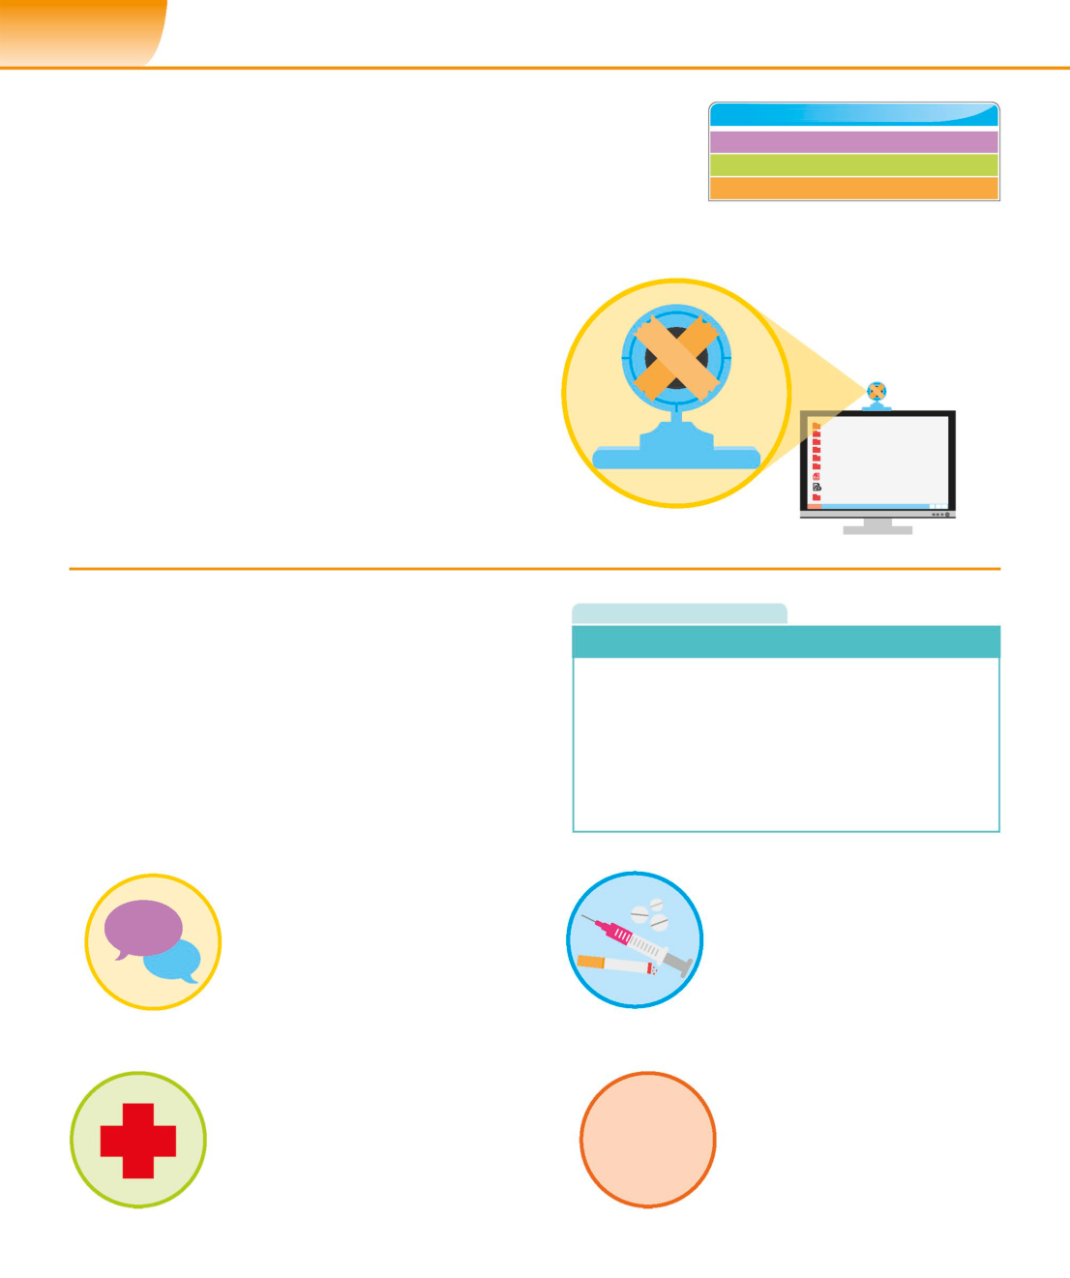

**186**  **D I G I TA L B E H A V I O U R S**

|  |  |
| --- | --- |
| Staying safe online | **SEE ALSO**  **‹22–23** Cybersecurity  **‹36–37** Peripheral devices |

|  |  |  |
| --- | --- | --- |
| **The internet is a useful tool both socially and educationally,** | Hacking and privacy | **190–191›** |

**but it also has its pitfalls. It’s essential that users are aware**

**of the dangers and ways to avoid them.**

**Keeping devices safe**  Cover webcam

with tape.

The first stage in staying safe online is to keep computers and   
mobile phones secure. All devices should have up-to-date   
virus protection. If using a public computer, in a library or   
at school, remember to log out of accounts before leaving.

▷**Webcam**

It’s possible for hackers to take control of your   
webcam and film without permission. Cover   
the webcam on a computer or phone with   
stickers, tape, or a cover when not in use.

**Dangerous content**  **R E A L W O R L D**

The internet gives access to many sites that parents would **Sharing personal information**

prefer young people not to see. These can include hate sites,

racist sites, websites that encourage anorexia or self-harm, It’s important for young people to develop a healthy level

and pornography. Discussing these issues with young people of distrust when interacting online, particularly if websites

can help counteract this kind of negative influence, as can or people ask them for personal information. Contact details,

encouraging them to evaluate what they read critically, such as email address, phone number, home address, and

comparing it with other sources of information. school, shouldn’t be given out to strangers. These can all be

used to identify someone’s location, which could potentially

put them in danger.

◁**Bigoted material**

Young people are often anxious to find a group ◁**Drugs**

where they belong, but this can make them The dark web is an underground

|  |  |  |
| --- | --- | --- |
| **#!$%*!** | prey to unpleasant ideologies. Sites that | part of the internet where illegal |

promote racism or sexism, or encourage drugs are readily available. It’s

|  |  |  |
| --- | --- | --- |
| **\*!#\*** | prejudiced views against minority groups | also easy to obtain potentially |

such as gay people, can encourage bad dangerous substances known

behaviour and, in some cases, criminal acts. as“legal highs”online.

◁**Self-harm** ◁**Pornography**

Young people who are under stress or It’s very easy for young people to

|  |  |  |
| --- | --- | --- |
| struggling with their mental health are | xxx | access sexually explicit content on the |
| particularly at risk from websites that | internet, as many sites don’t require any |

encourage self-harm or suicide. Sites payment. Activating parental controls

that promote anorexia also exist and on devices and internet connections can

can endanger vulnerable teenagers. help restrict access to these sites at home.

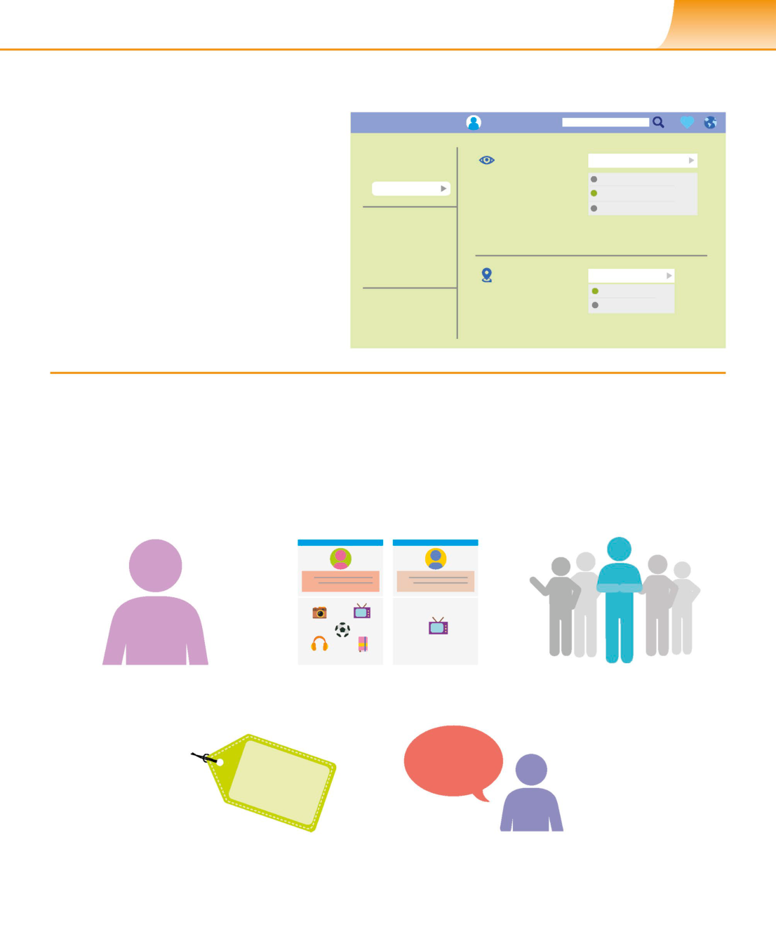

S TAY I N G S A F E O N L I N E **187**

**Social media**

Although it is a positive way to connect with friends,

|  |  |  |
| --- | --- | --- |
| social media can often be stressful for young people. | **Home** | **Profile** |

This could be due to unrealistic pressures to look a

certain way, or unkind comments from others. There’s

|  |  |  |
| --- | --- | --- |
| also the danger of private messages or pictures | **General** | **Visible to** |

being circulated widely. Parents can help by making All

|  |  |  |
| --- | --- | --- |
| kids aware of these issues and discussing practical | **Privacy** | My Friends |

ways to avoid feelings of inadequacy. Boosting their Only me

confidence and making them aware of their right to **Blocking**

say no can also help.

**Notification**

**Public**   
 **Geolocation**

|  |  |  |
| --- | --- | --- |
| ▷**Privacy settings** | **Support** | Off |
| Social media privacy settings allow users to | On |

hide their posts so that strangers can’t access

them. Disabling location settings can stop

people from identifying where a person is.

**False identities**

While chatting with new people on the internet can be a great way

to make friends and connect with people with shared interests, it ▽**Fake profiles**

can also present some dangers. People don’t have to use real photos People who want to insult or antagonize others

of themselves, or their real name, or be telling the truth about online – also known as“trolling”– often set up a new

anything they say. While this can be a way for users to explore their profile under a fake name so their activities are hard

identities, it is unfortunately also possible for criminals to use it as a to trace back to them. As a result, it’s usually relatively

way to contact young people. easy to spot these social media profiles.

?

|  |  |  |
| --- | --- | --- |
| A fake profile often doesn’t | Fake profiles may not include much | Having an extremely small |

|  |  |  |
| --- | --- | --- |
| include a photo or uses a very | personal information, while real profiles | number of friends or followers |

|  |  |  |
| --- | --- | --- |
| artificial-looking generic photo. | list information like interests or job. | is another feature to be wary of. |

**%&$@&%@##**

Fake profiles sometimes use screen A account that posts abusive

names made of a series of random content only is most likely

letters and numbers. a fake account.

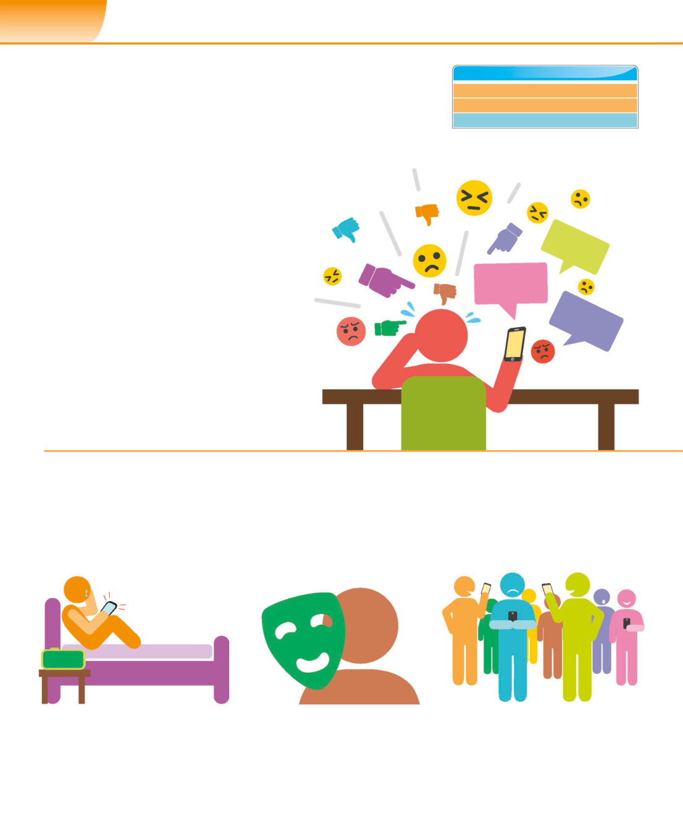

**188**  **D I G I TA L B E H A V I O U R S**

|  |  |
| --- | --- |
| Cyberbullying | **SEE ALSO**  **‹180–181** Maintaining balance  **‹182–183** Being a digital citizen |

|  |  |  |
| --- | --- | --- |
| **Coupled with the rise of instant online communication is** | What is social media? | **194–195›** |

**an increase in online bullying, but support from parents**

**and teachers can really help with upsetting interactions.**

**What is cyberbullying?**

Threatening or embarrassing someone using

internet-connected devices is called cyberbullying.

This can happen in many forms, including sending

threatening or unpleasant text messages, impersonating

someone online in order to obtain information, posting

personal information without someone’s consent,

setting up a poll about someone, passing on secrets,

and threatening to make information public.

▷**How it feels to be a victim**

Cyberbullying can make the victim feel scared and

isolated. They may feel embarrassed and ashamed

about what is being said about them, which can

make it harder for them to ask for help.

**What makes it different?**

Unfortunately, bullying is fairly common in schools and among

groups of young people, but cyberbullying has features that mark

it out as different. Some of these make it easier to identify the bully

and deal with the problem, but others make it much more difficult.

**02:15 AM**

|  |  |  |
| --- | --- | --- |
| △**Any time** | △**Anonymous** | △**Large audience** |

|  |  |  |
| --- | --- | --- |
| Cyberbullying can happen around the clock, | Cyberbullies have the ability to remain | Cyberbullies can reach large audiences very |

|  |  |  |
| --- | --- | --- |
| even in the victim’s home where, before | anonymous, and tracing the source can | quickly, increasing the victim’s distress. Many |

|  |  |  |
| --- | --- | --- |
| internet and mobile devices, they would | be extremely difficult, meaning that the | people can become complicit by passing on |

|  |  |  |
| --- | --- | --- |
| have been safe from this kind of abuse. | victim doesn’t know who to trust or blame. | a bullying image or remark. |

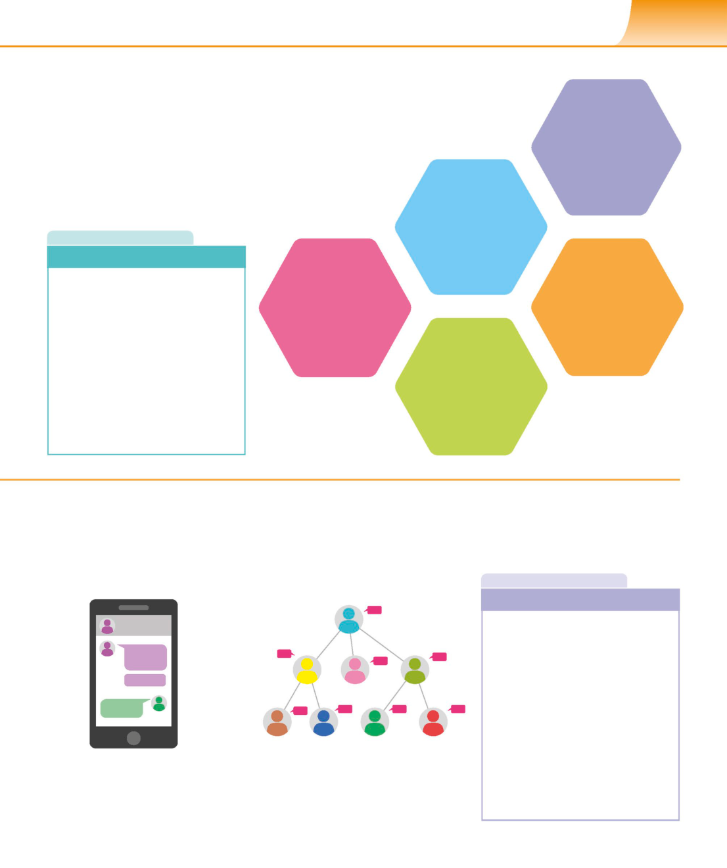

C Y B E R B U L LY I N G **189**

**Dealing with cyberbullying**

There are a number of ways to deal with

cyberbullying. The best way for young people to **Save online**

respond to the problem is by blocking bullies on **conversations and**

social media and reporting offensive behaviour **screen shots of websites**

to the site. Contacting a bullying helpline can **that contain bullying**

also be useful, along with telling family or friends **messages or images**

so that they can provide support. **as evidence.**

**Contact a helpline for**   
**young people struggling**

|  |  |
| --- | --- |
| **R E A L W O R L D** | **with issues like bullying**  **to access advice** |

**Cyberbullying and the law**  **and support.**

|  |  |  |
| --- | --- | --- |
| Cyberbullying isn’t a specific criminal | **Blockandreport** | **Tellfamilymembers,** |
| ofenceinmostcountries,butthere | **the bully if they are** | **friends, or teachers, as** |
| areoftenlawsthatrelatetobehaviour | **usingsocialmedia** | **theycanprovidesupport** |
| or communications that can apply | **or a public website.** | **and practical help.** |
| to cyberbullying. As the problem |

becomes more widespread, police   
and prosecutors are starting to issue **Don’t retaliate or reply**   
guidelines on these laws. Remarks **to the bully as this**

made on social media may also lead **may simply encourage**

to people being sued for defamation **them to continue.**   
in the civil courts.

The ability to **make comments**

**anonymously** often **brings**

**out the worst** in people.

**I N D E P T H**

**Why do people do it?**

**Govind**  There are a variety of reasons why   
 young people may become involved   
 in cyberbullying behaviour. If they have   
 been the victims of bullying, or have   
 problems at home, they may take it   
 out on others. Some see it as a way to   
 increase their popularity at the expense   
 of others. Young people may feel   
 uncomfortable about being involved   
 in a group that’s picking on someone,

|  |  |  |
| --- | --- | --- |
| △**Evidence** | △**Thoughtless remarks** | but don’t have the confidence to point |

|  |  |  |
| --- | --- | --- |
| In cases where the bullying isn’t anonymous, | Some instances of cyberbullying aren’t | out and stop the bad behaviour. |

online messages or incidents are evidence intentional. A thoughtless remark might   
of the bully’s behaviour and can be shown unintentionally hurt someone after it is   
to teachers or the police. shared by many people.

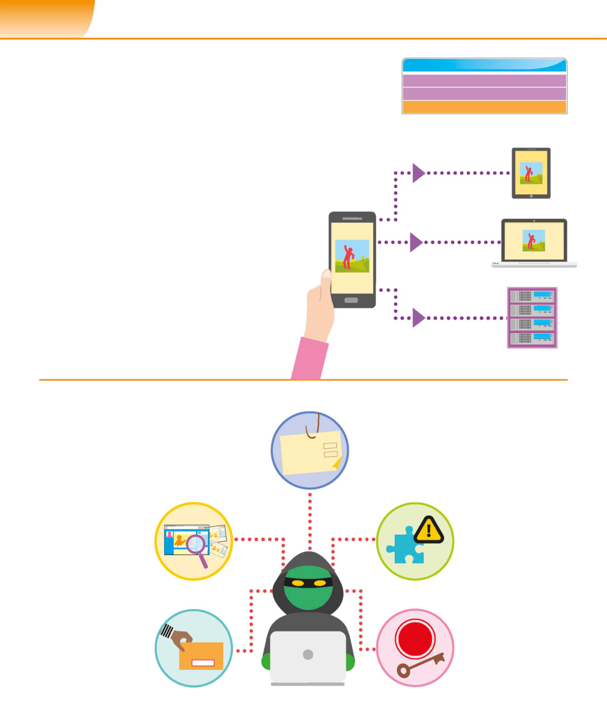

**190**  **D I G I TA L B E H A V I O U R S**

|  |  |
| --- | --- |
| Hacking and privacy | **SEE ALSO**  **‹22–23** Cybersecurity  **‹156–157** Malware |

**Every internet user creates data that could be harvested for** **‹186–187** Staying safe online

**malicious purposes. It’s important to understand the potential**

**pitfalls in order to minimize the risks.**

**Nothing is private**  A picture can be

As a rule of thumb, assume that nothing posted on copied and stored   
 on multiple devices.

the internet will be kept private. Account settings   
might restrict who can view posts on social media, **Copied to a tablet**

but it’s easy enough to download pictures or take   
screenshots. The pictures can then be shared and   
re-uploaded at any time. Many websites also have   
automatic backups, so deleting content only removes   
it from the main website directory and doesn’t   
necessarily get rid of copies. **Copied to a laptop**

▷**Privacy on the internet**   
To stay safe, avoid posting anything   
online that you wouldn’t be comfortable   
for strangers to know about you. **Copied to a server**

**Hacking**

Making a piece of technology do something it ◁**Phishing**

wasn’t designed to do is called hacking. A common Tricking a person into

example is bypassing software security to illegally entering their credentials in   
 a fraudulent website. Mockups

access someone else’s account. There are many

often mimic legitimate social

types of hacking, but they can all be avoided

media sites or banks.

with the right precautions.

▷**Social engineering** ◁**Fake browser extensions**

Studying a person’s social Tricking someone   
media account to gain into downloading

information that could a malicious extension

be used to help guess that tracks browsing   
or steal a password. habits or even posts   
 from logged-in accounts.

▷**Password grabbing**

If a user tends to reuse the

same password for many ◁**Keyloggers**   
sites, stealing it once from a Once downloaded,

|  |  |  |
| --- | --- | --- |
| low-security website means | **REC** | keyloggers record user key |

|  |  |  |
| --- | --- | --- |
| that they have access to all | **Password** | presses and send data, such |

|  |  |  |
| --- | --- | --- |
| the sites the password has | **\*\*\*\*** | as passwords, back to the |

been used for. original hacker.



H A C K I N G A N D P R I V A C Y **191**

**Browsing habits**  **Prevention**

Online browsing can be compared to dropping crumbs. The best advice for preventing data theft is obvious: only   
A single crumb isn’t a big deal, but many crumbs create visit trusted websites; be selective about social media posts;

a mess. Most users aren’t even aware of what information if a problem is identified or even suspected, address it   
they’re giving away when browsing the internet. Continuously right away. For advanced protection, consider two-factor   
harvesting these small, harmless pieces of data can lead to authentication (2FA) and encryption services. While it might   
serious privacy breaches. To prevent this, it’s important be annoying to go through extra security steps online, in

to understand how user data is created and monitored. the long term, it’s a small price to pay for maintaining privacy

and preventing problems.

**Cookies** ◁**Anonymous browsing**

|  |  |
| --- | --- |
| Cookies are small pieces of data that websites use to store  information about a user’s browsing session. Along with  the IP address and search history, they can be used to  create a detailed portrait of a user’s habits and interests. | When browsing in a private or  incognito window, no cookies are  stored. Your search history, download  history, and search queries aren’t  recorded and therefore can’t be stolen. |

**Privacy settings** ◁**Proxy servers**

When installing a new app, many people hit the These servers are used to hide the IP

“I agree”button without reading the software licence address, making it difficult to tell what

agreement. This potentially makes it possible for apps websites the user is visiting. It’s just like

to collect personal information without the user’s using someone else’s phone to call a

knowledge, but with their permission. taxi – the taxi will still turn up, but they

have no information about you.

**IP addresses**

◁**Clearing data**

An IP address is a 32-bit or 128-bit unique number

When using a regular browser, make

used to identify a computer. An eavesdropper on

sure you clear the history, cache, and

a network can use this IP address to monitor the

cookies periodically. You can also

websites a user is visiting.

configure the browser to automatically

clear these after each browsing session.

**R E A L W O R L D**

**Targeted Advertising**

Targeted advertising is

|  |  |  |  |
| --- | --- | --- | --- |
| **Books** | **Search** | designed to show people | **I N D E P T H** |

|  |  |  |  |
| --- | --- | --- | --- |
| **Search results...** | **Ads** | content they’re interested | **Parental advice** |

in. If someone’s browsing

history contains a lot of Keeping kids safe online means teaching them responsible

travel websites, they might browsing habits. Update the browser settings to block adult

be shown ads for flight content and periodically check their browser history. Have

discounts and holiday conversations about online safety. Parents of younger kids

packages. While targeted may also want to have access to their passwords, but for

advertising isn’t a violation teenagers, there’s a fine line between safety and privacy.

of privacy, it reveals how If you decide to use GPS tracking apps or monitoring

much information can software, it’s better to be open about it.

be obtained by studying

search histories.